School Name
Mathematics Test 2017
Year 9 |  | Basic Geometry | Non Calculator
Skills and Knowledge Assessed:  - Use the language, notation and conventions of geometry  - Identify line and rotational symmetries (ACMMG181)  - Recognise the geometrical properties of angles at a point.  - Identify corresponding, alternate and co­interior angles when two straight lines are crossed by a  transversal (ACMMG163)  - Investigate conditions for two lines to be parallel and solve simple numerical problems using reasoning (ACMMG164)  - Demonstrate that the angle sum of a triangle is 180° and use this to find the angle sum of a quadrilateral (ACMMG166)  - Classify triangles according to their side and angle properties and describe quadrilaterals (ACMMG165)  - Establish properties of quadrilaterals using congruent triangles and angle properties, and solve related numerical problems using reasoning (ACMMG202) |  |  | Name_________________
Section 1 Short Answer Section
JUSTIFY YOUR ANSWER WITH REASONS/ CALCULATIONS WHERE NECESSARY.
YOU WILL NEED A RULER AND PROTRACTOR FOR THIS TEST.
Write all working and answers in the spaces provided on this test paper.
DIAGRAMS ARE NOT TO SCALE. (Unless otherwise stated).
Describe any line and rotational symmetry properties of the shape below.
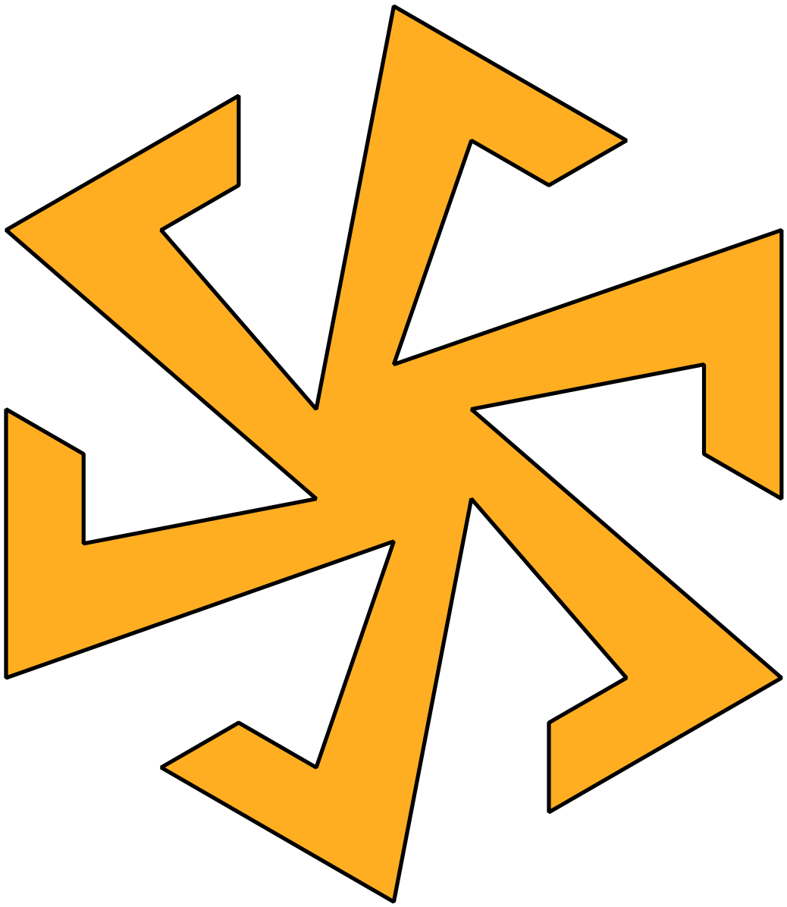

……………………………………………………………………………………………....

……………………………………………………………………………………………….
Shade in the angles which would be named 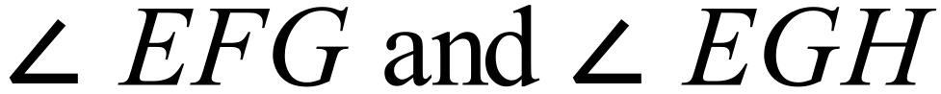 in the diagram below.
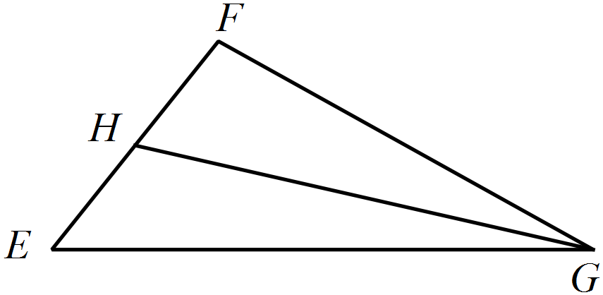

A rectangle ABCD is shown below. E and F are points on the side BC.
Describe and name the shape which has been shaded, by listing its vertices.
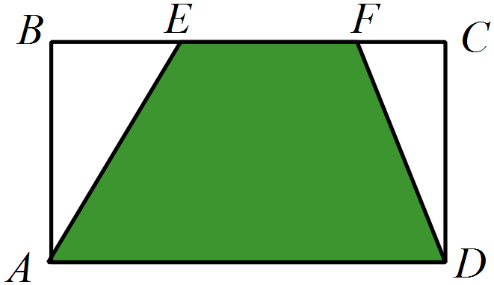

……………………………………………………………………………………………....

……………………………………………………………………………………………….
Name an obtuse angle in the diagram below.
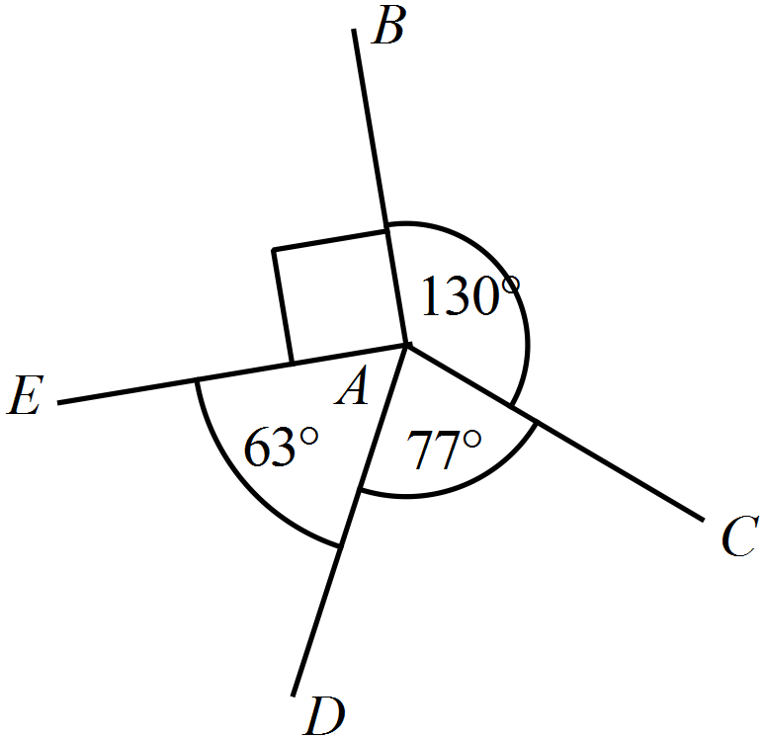

……………………………………………………………………………………………....

……………………………………………………………………………………………….
The angles marked 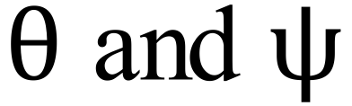 are equal in size.
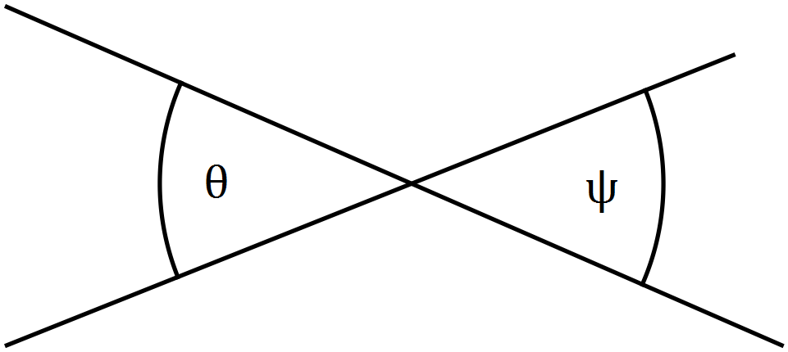What name is given to this type of angle pair?

……………………………………………………………………………………………….
Find the value of p in the diagram below.
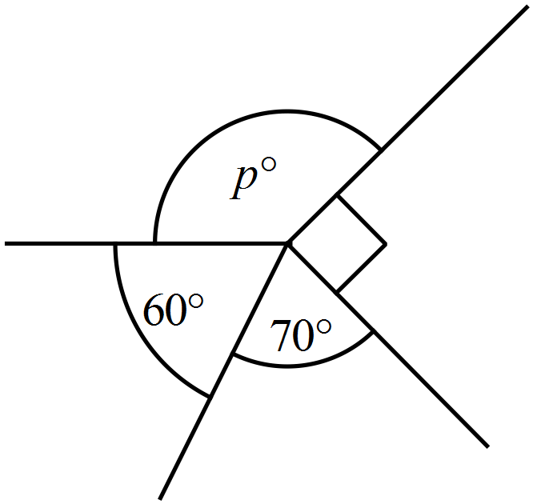

……………………………………………………………………………………………....

……………………………………………………………………………………………….
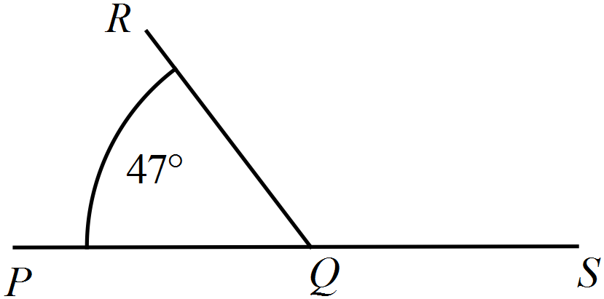What is the size of 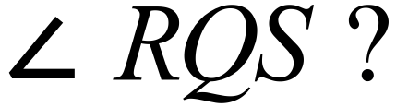

……………………………………………………………………………………………....

……………………………………………………………………………………………….
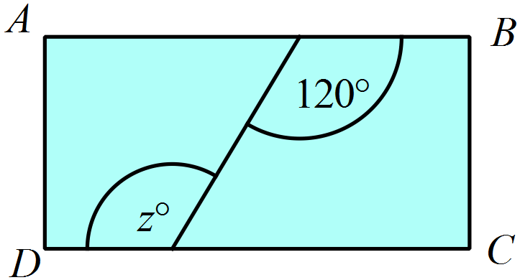ABCD is a rectangle.
What is the value of z?

……………………………………………………………………………………………....

……………………………………………………………………………………………….
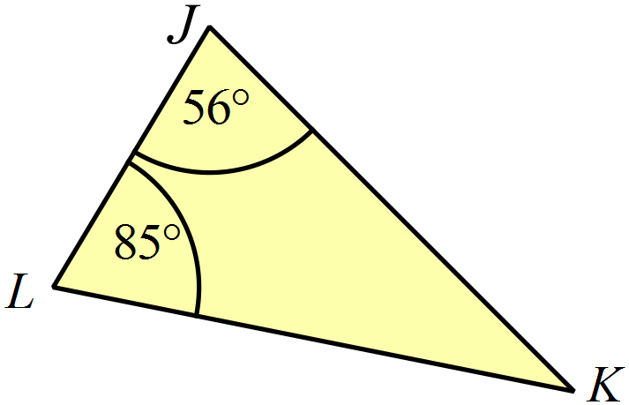What is the size of 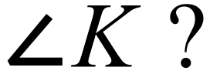

……………………………………………………………………………………………....

……………………………………………………………………………………………….
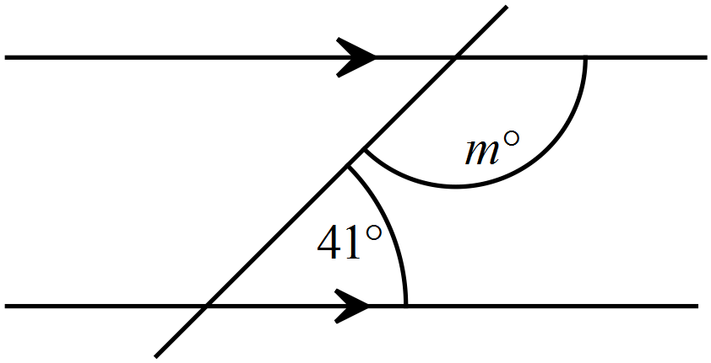What is the value of m?

……………………………………………………………………………………………....

……………………………………………………………………………………………….
Measure the size of 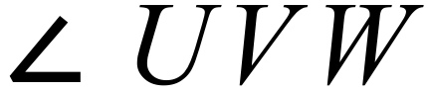 correct to the nearest degree.
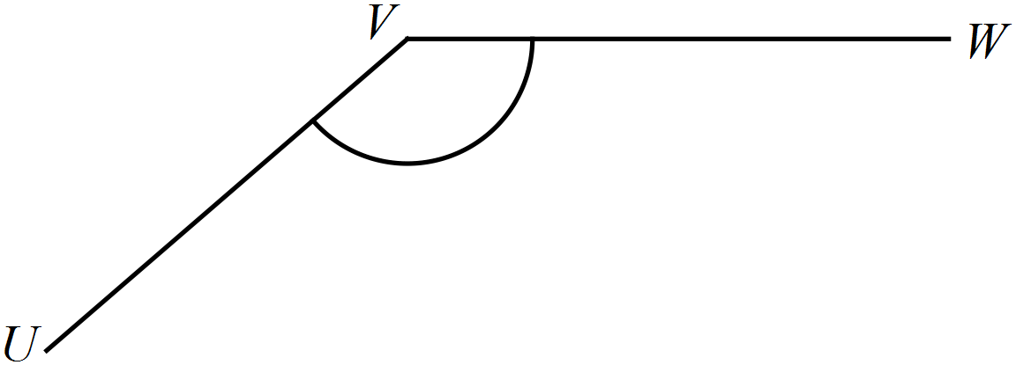

……………………………………………………………………………………………….
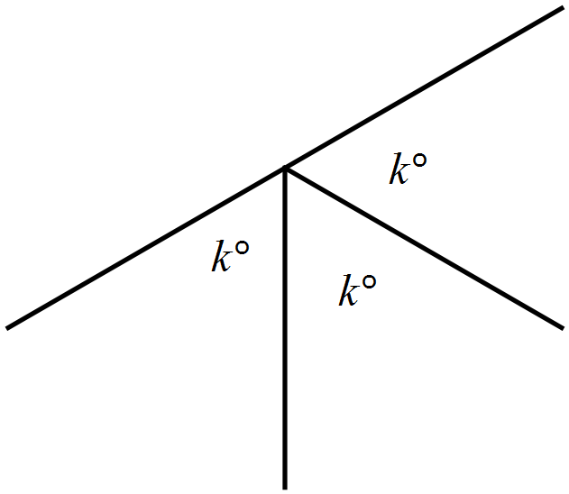Find the value of k.

……………………………………………………………………………………………....

……………………………………………………………………………………………….
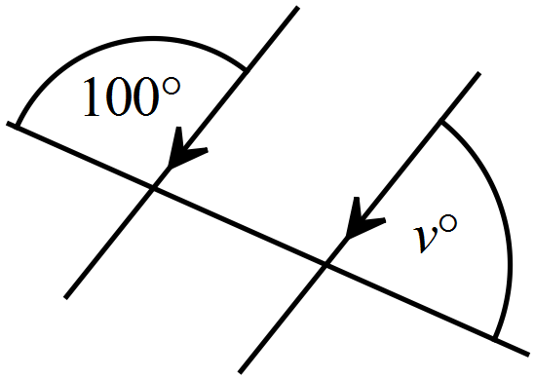Find the value of v.

……………………………………………………………………………………………....

……………………………………………………………………………………………….
A 1 cm isometric grid is shown below.
Use the grid to sketch an obtuse isosceles triangle.
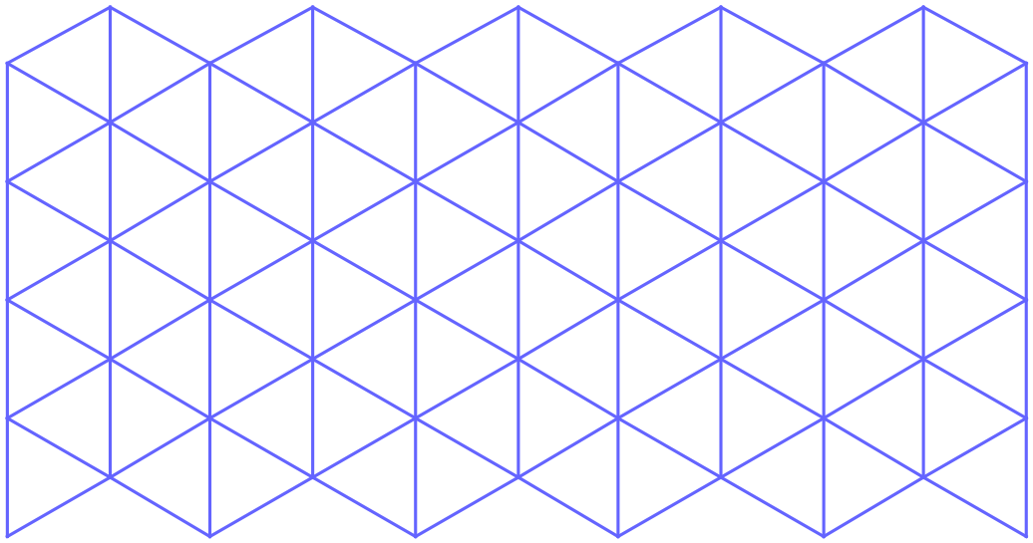

Find the size of 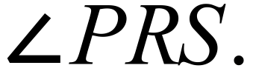
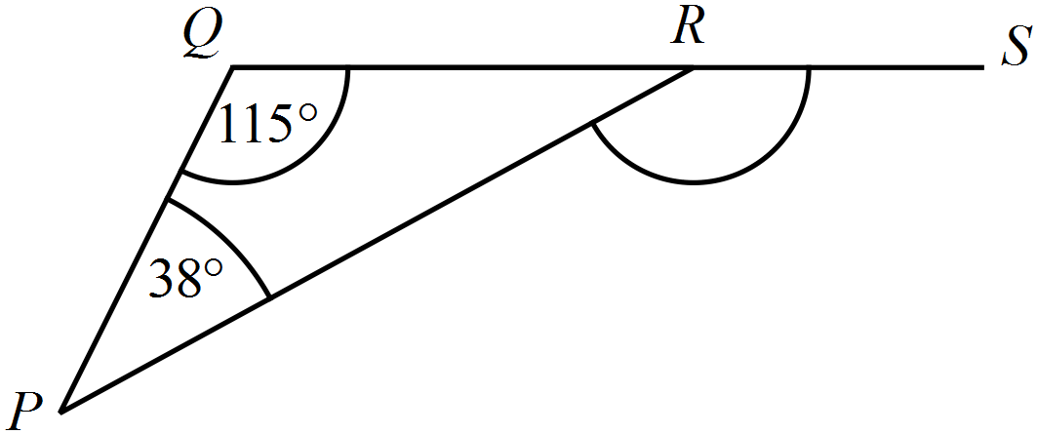

……………………………………………………………………………………………....

……………………………………………………………………………………………….
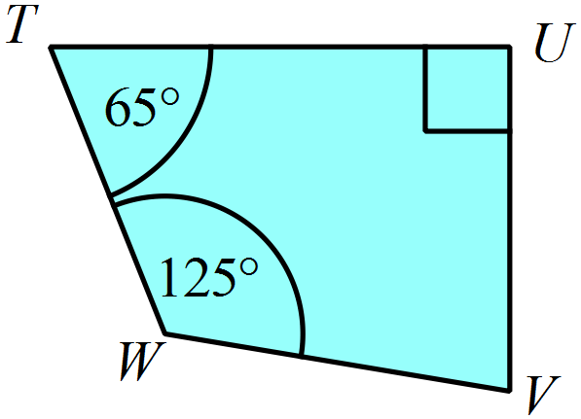Find the size of 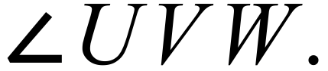

……………………………………………………………………………………………....

……………………………………………………………………………………………….
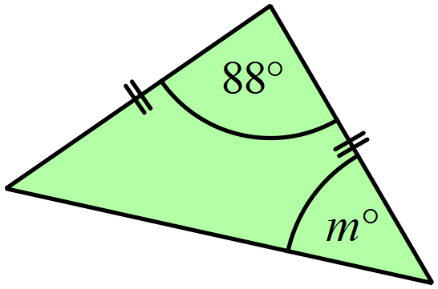Find the value of m.

……………………………………………………………………………………………....

……………………………………………………………………………………………….
A quadrilateral has diagonals which are unequal in length, but which bisect one another.
Sketch and name the quadrilateral.

……………………………………………………………………………………………….
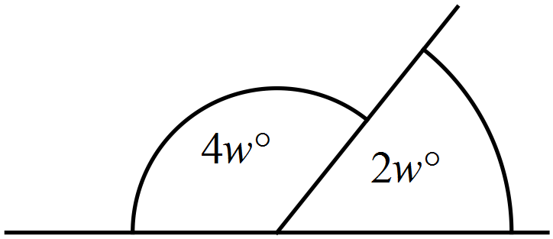Find the value of w.

……………………………………………………………………………………………....

……………………………………………………………………………………………….
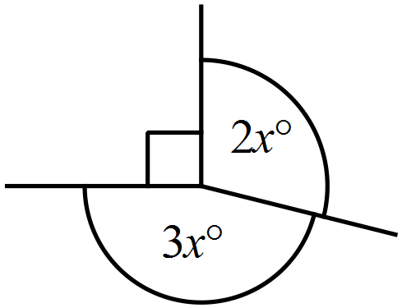Find the value of x.

……………………………………………………………………………………………....

……………………………………………………………………………………………….
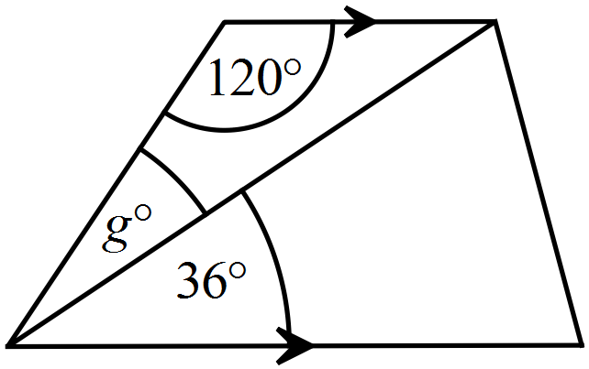Find the value of g.

……………………………………………………………………………………………....

……………………………………………………………………………………………….
Using the angles given in the quadrilateral below, explain why AB || DC.
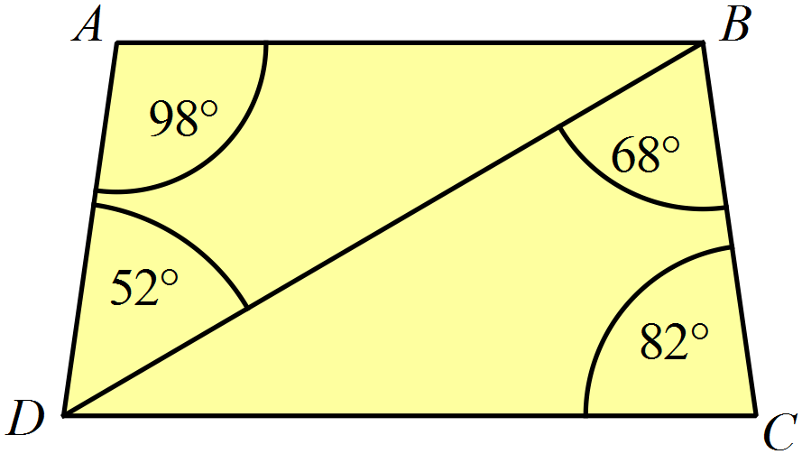

……………………………………………………………………………………………....

……………………………………………………………………………………………....

……………………………………………………………………………………………….
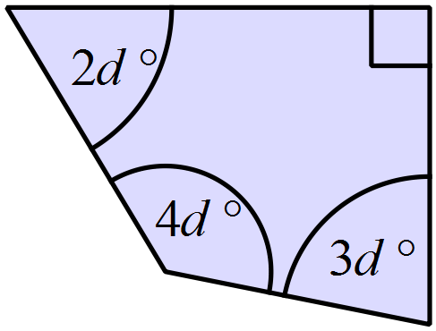Find the value of d.

……………………………………………………………………………………………....

……………………………………………………………………………………………….
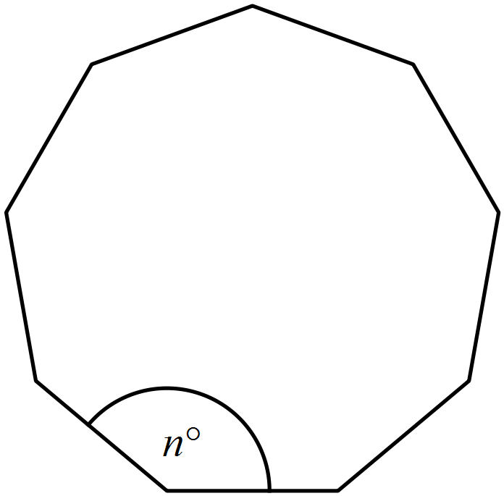A regular nonagon (nine-sided polygon) is shown.
What is the value of n?

……………………………………………………………………………………………....

……………………………………………………………………………………………….
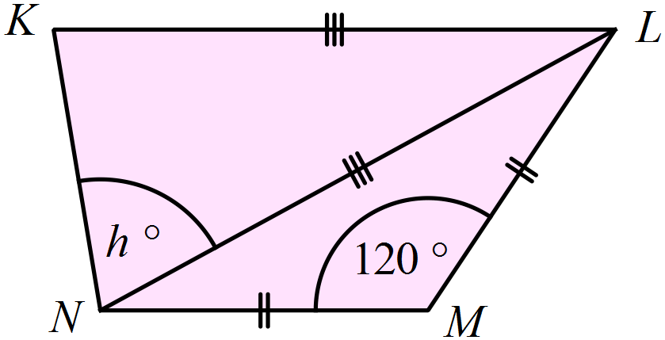In the diagram KL || NM, KL = NL and NM = ML.
Find the value of h.

……………………………………………………………………………………………....

……………………………………………………………………………………………….
PQRS is a rhombus and PQRT is a kite.
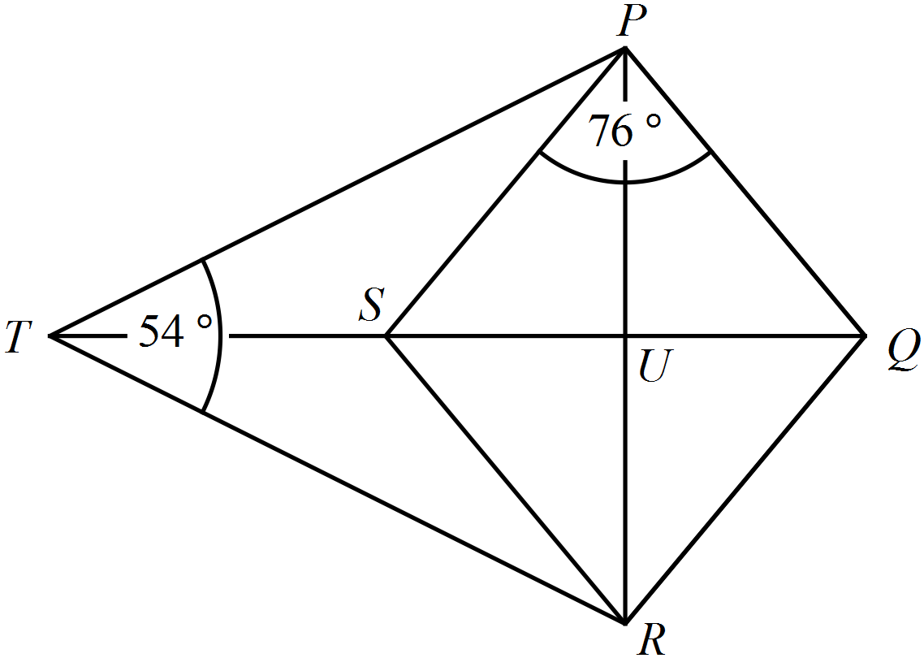What is the size of 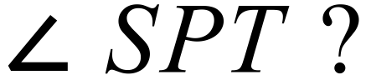

……………………………………………………………………………………………....

……………………………………………………………………………………………….

School Name
Mathematics 2017
Year 9 | Basic Geometry | Calculator Allowed
Year 9 | Basic Geometry | Name_________________
Section 2 Multiple Choice Section
Mark all your answers on the accompanying multiple choice answer sheet, not on this test paper. You may do any working out on this test paper. Calculators are allowed for this section.

Which statement is true about the shape below?


A. The shape has both line symmetry and rotational symmetry.
B. The shape has line symmetry only.
C. The shape has neither line symmetry nor rotational symmetry.
D. The shape has rotational symmetry only.
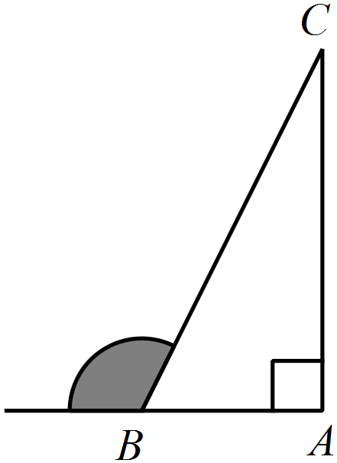Which diagram shows 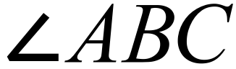 which is a reflex angle?
A. B.
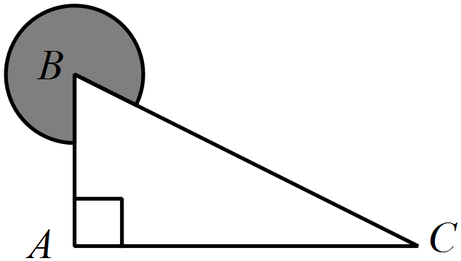

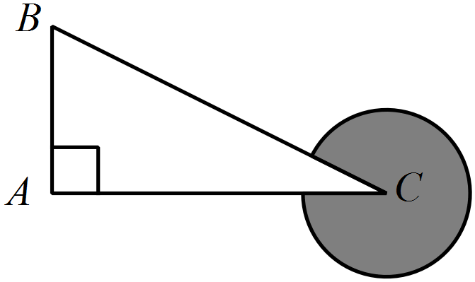 C. D.
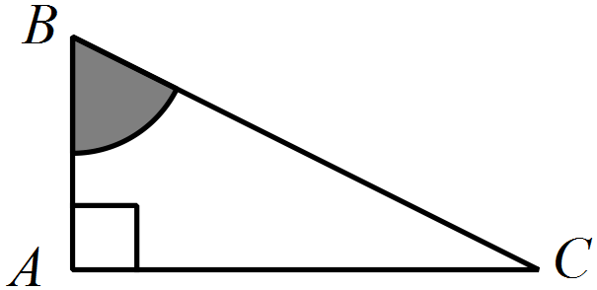

Questions 3 and 4 refer to the regular octagon shown below.
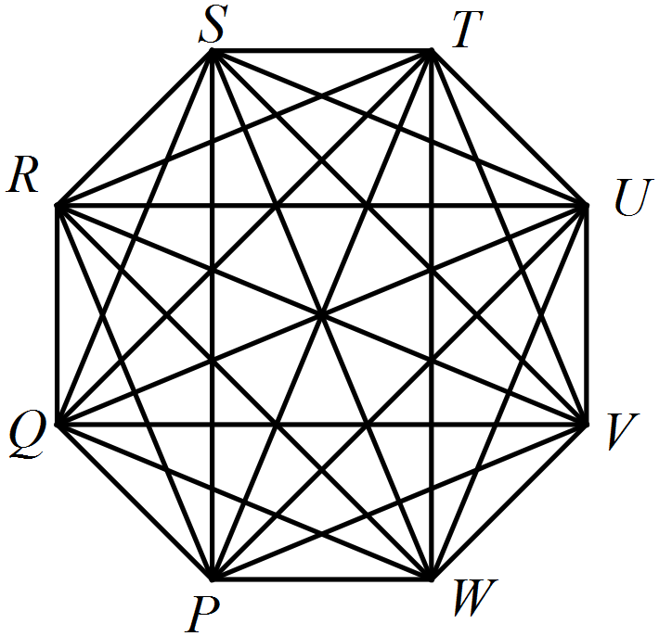

What name best describes the shape PQRS?

A. Parallelogram B. Rectangle C. Rhombus D. Trapezium
How many diagonals does the octagon have?

A. 16 B. 20 C. 32 D. 40
Use a protractor to determine the size of 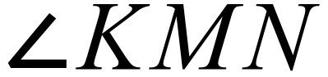 in the quadrilateral below, correct to the nearest degree.
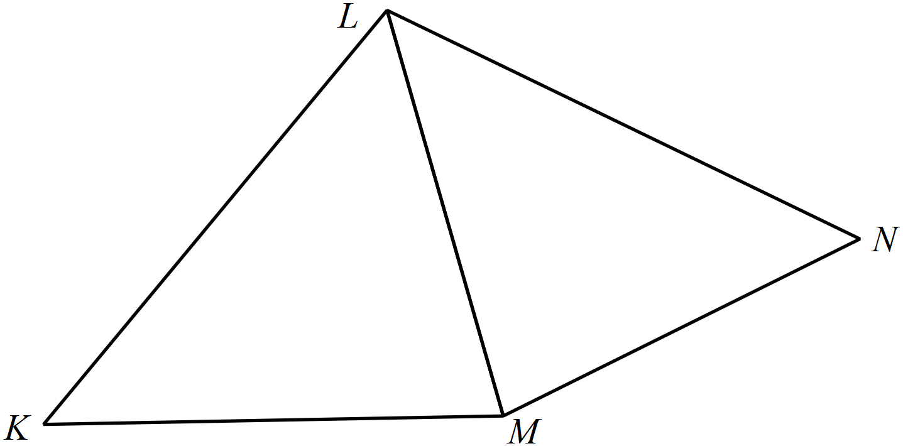

A. 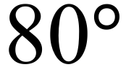 B. 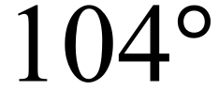 C. 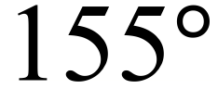 D. 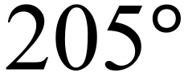
What is the value of p in the diagram below?
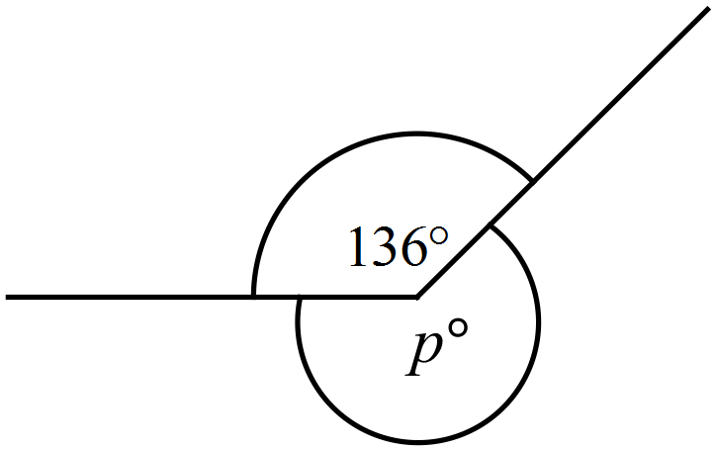

A. 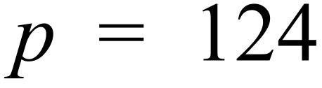 B. 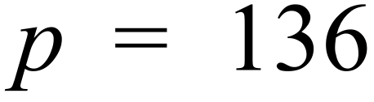 C. 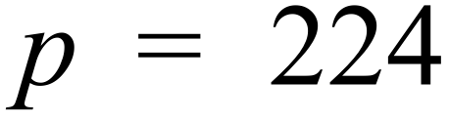 D. 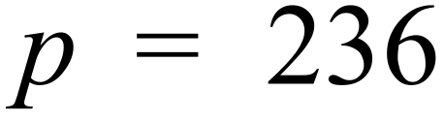
The shape below is a parallelogram.
What is the value of z?

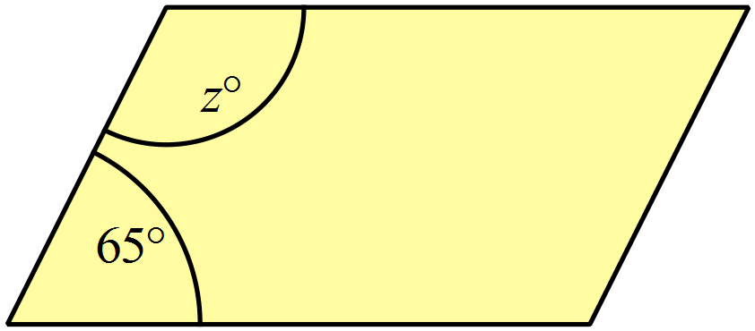

A. z = 25 B. z = 65 C. z = 115 D. z = 155
What is the size of 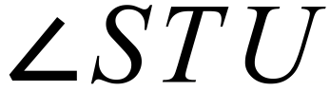 in the diagram below?
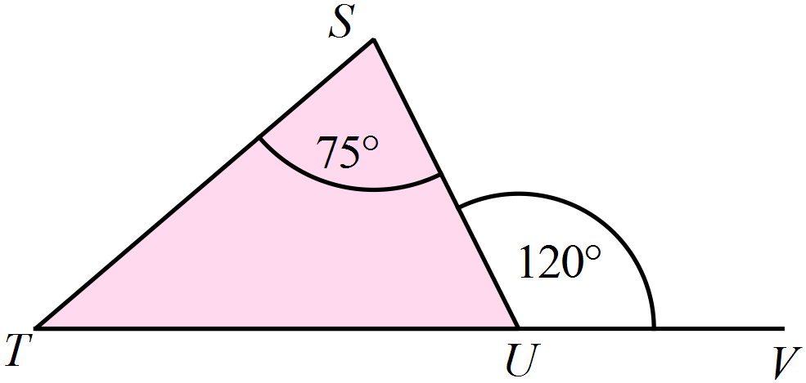

A. 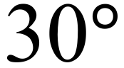 B. 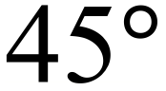 C. 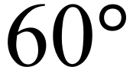 D. 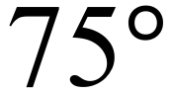
What is the value of e in the diagram below?
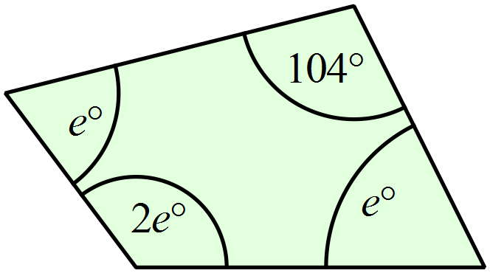

A. e = 64 B. e = 72 C. e = 85.3 D. e = 128
What is the value of q?
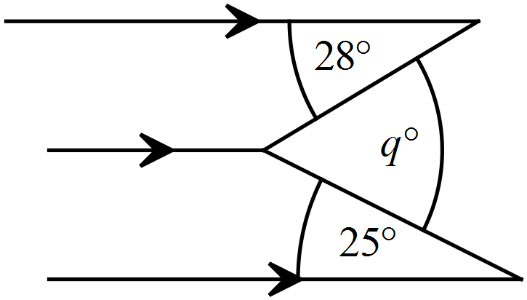

A. 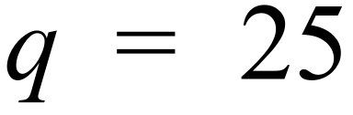 B. 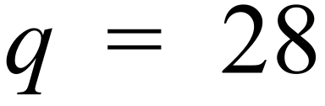 C. 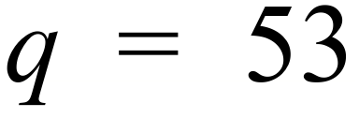 D. 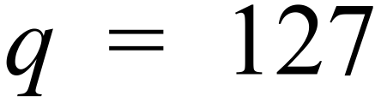
A quadrilateral has the properties below:
- Its diagonals are unequal.
- Its diagonals bisect one another.
- The angle between its diagonals is 40º.
What name would best describe the quadrilateral?

A. Parallelogram B. Rectangle C. Rhombus D. Trapezium
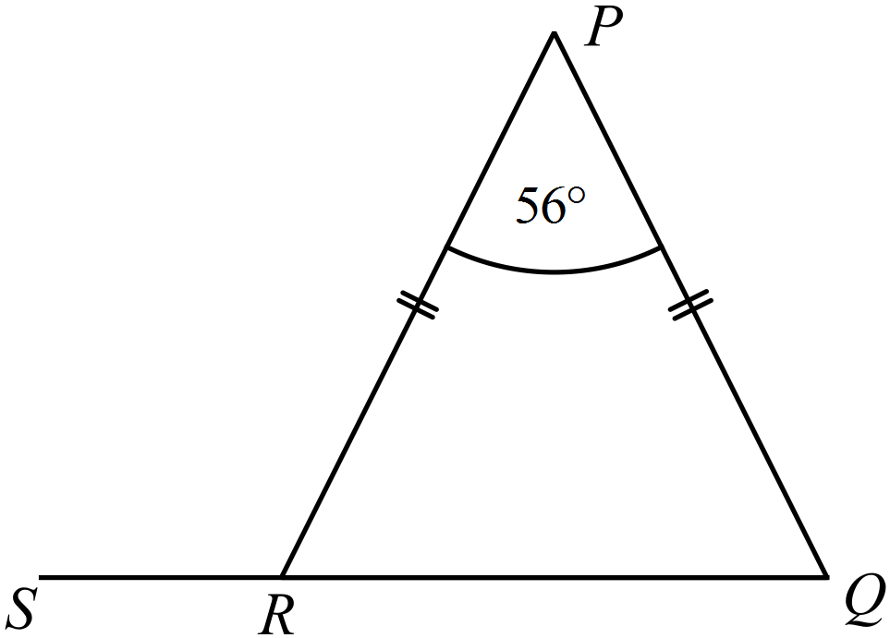An isosceles triangle is shown below.
Find the size of 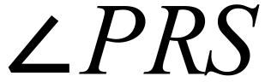

A. 56º B. 62º C. 118º D. 124º
There are two right angles and four other equal angles in the hexagon shown below.
What is the value of d ?

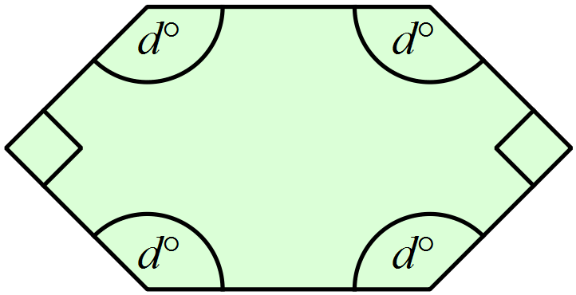

A. d = 90 B. d = 108 C. d = 120 D. d = 135
A rhombus, which has one of its internal angles equal to 66º, has it two diagonals drawn.
Which type of triangle is not formed in the resulting figure?
A. An acute isosceles triangle.
B. An acute equilateral triangle
C. An obtuse isosceles triangle
D. A right scalene triangle.
What is the value of d in the diagram below?

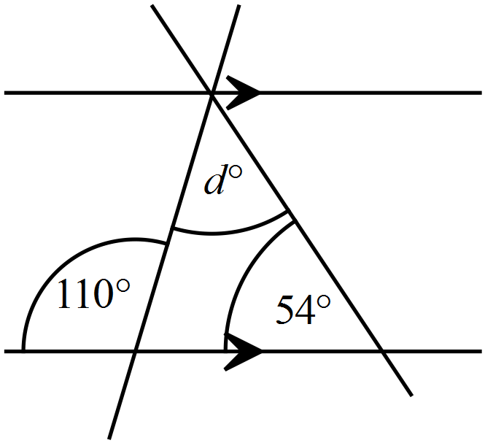

A. 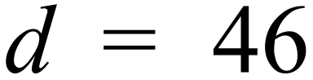 B. 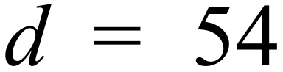 C. 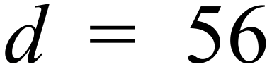 D. 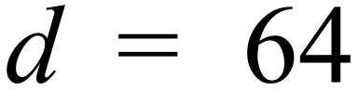
What is the size of 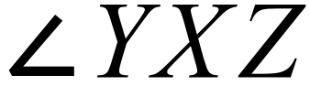 in the diagram below?
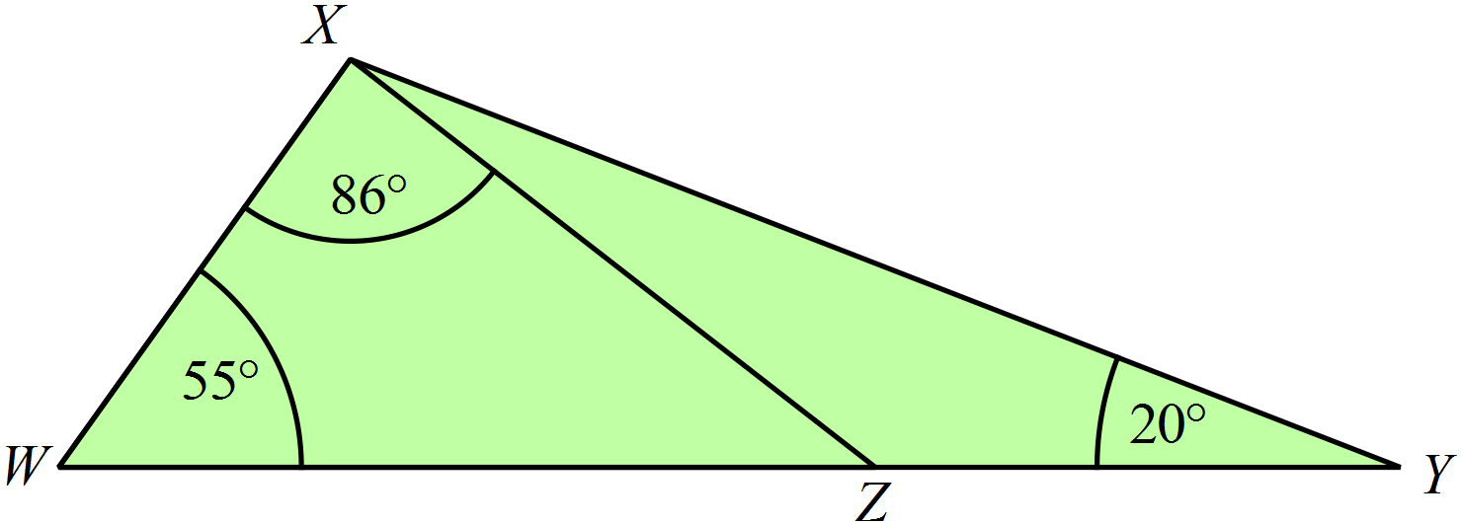

A. 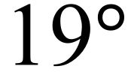 B. 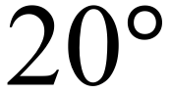 C. 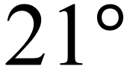 D. 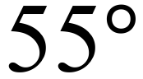
What is the value of w in the diagram below?
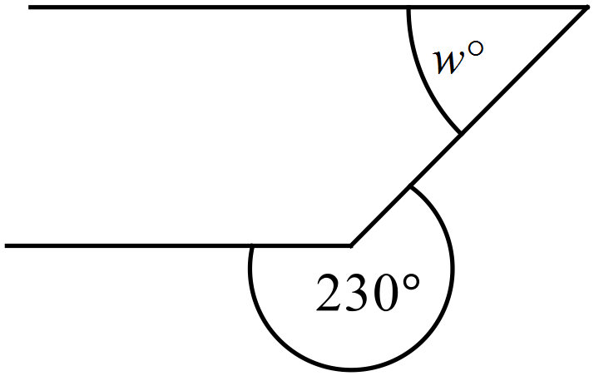

A. 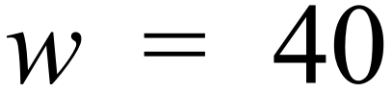 B. 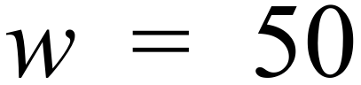 C. 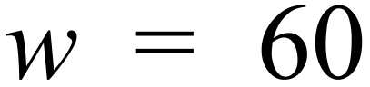 D. 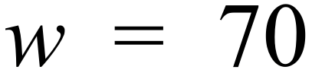
What is the value of x?
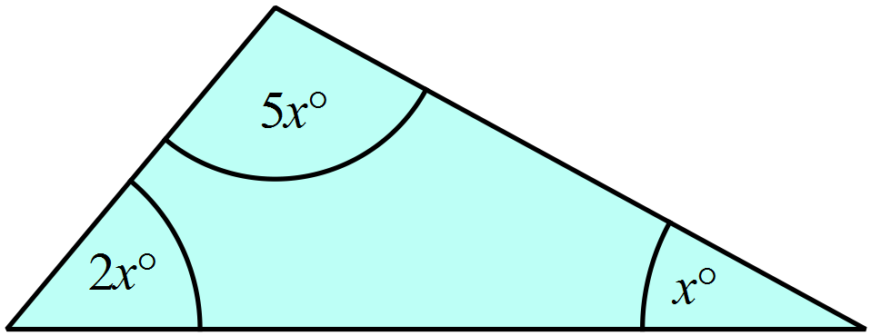

A. 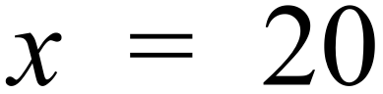 B. 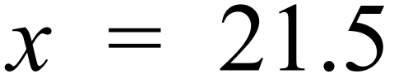 C. 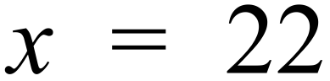 D. 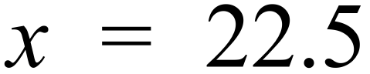
What is the value of c in the diagram below?
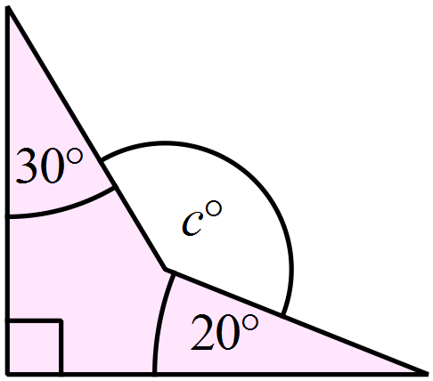

A. 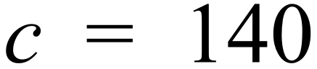 B. 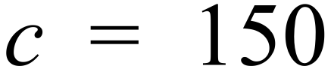 C. 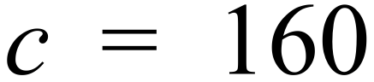 D. 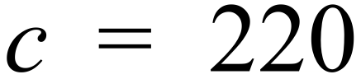
What is the value of y in the diagram below?
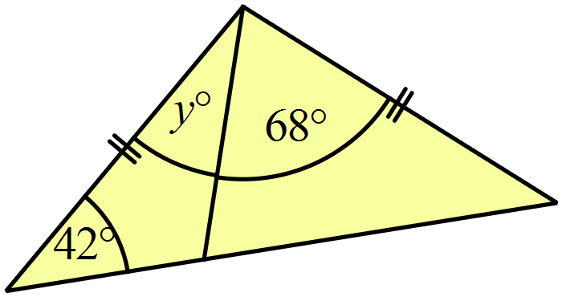

A. 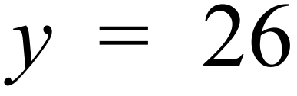 B. 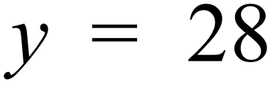 C. 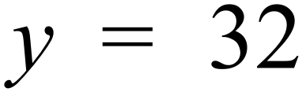 D. 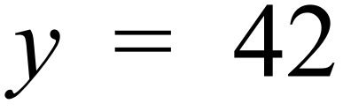

School Name
Mathematics 2017
Year 9 | Basic Geometry | Calculator Allowed
Year 9 | Basic Geometry | Name___________________
Section 3 Longer Answer Section
Write all working and answers in the spaces provided on this test paper.

 |  | Marks
1. | Complete the following using geometric instruments.  Do not erase any of your construction lines.
 | (a) Draw an isosceles triangle that has an angle of 80º between its equal sides which each measure 7 cm. | 2
 | (b) A diagonal AC of a rhombus is shown below.  The diagonal BD of the rhombus measures 6 cm in length.  Construct the diagonal BD and draw the rhombus. | 2

School Name
Mathematics 2017
Multiple Choice Answer Sheet
Basic Geometry
Name _____________________________________________
Completely fill the response oval representing the most correct answer.
1. A B C D
2. A B C D
3. A B C D
4. A B C D
5. A B C D
6. A B C D
7. A B C D
8. A B C D
9. A B C D
10. A B C D
11. A B C D
12. A B C D
13. A B C D
14. A B C D
15. A B C D
16. A B C D
17. A B C D
18. A B C D
19. A B C D
20. A B C D

School Name
Mathematics Test 2017
Year 9 | Basic Geometry | Non Calculator Section
ANSWERS

Question | Working and Answer
 | The shape has no line symmetry and has rotational symmetry of order 6.
 | 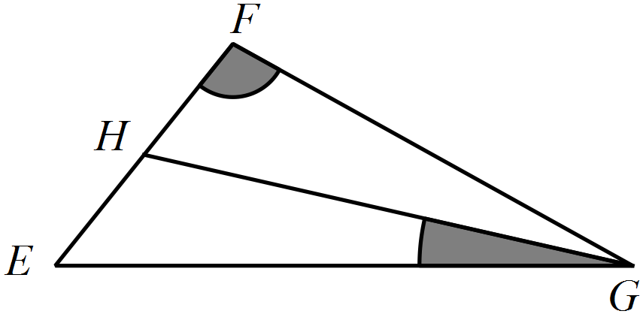
 | It is the trapezium AEFD.
 | 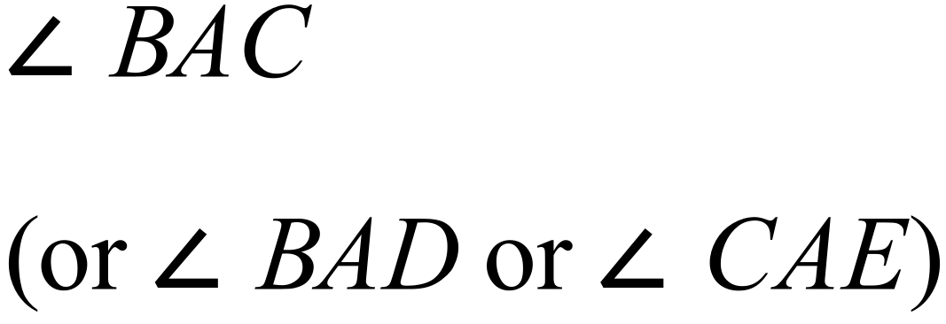
 | Vertically opposite angles.
 | 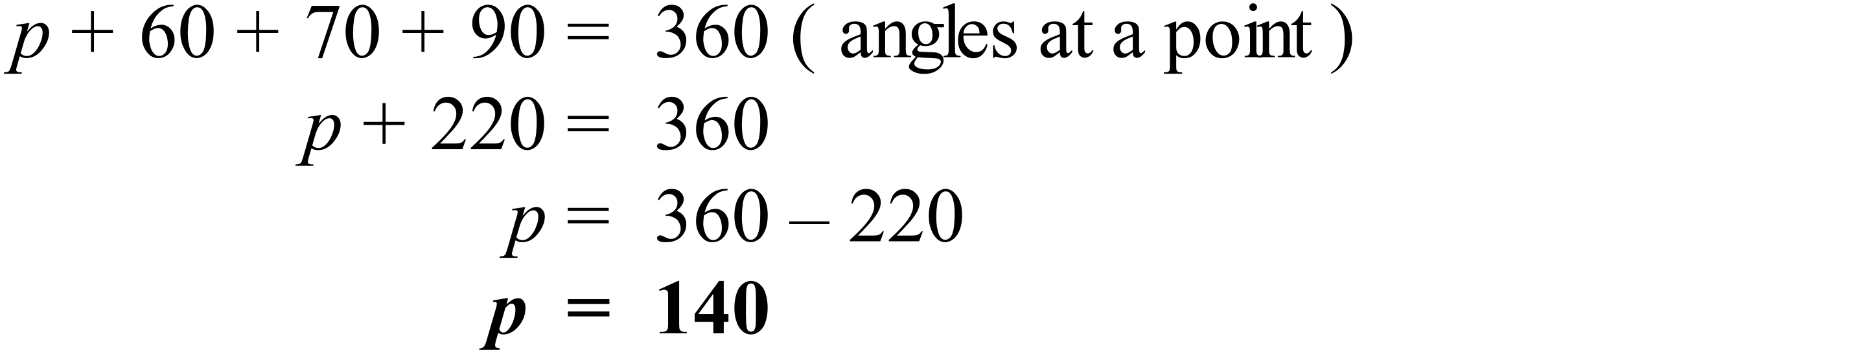
 | 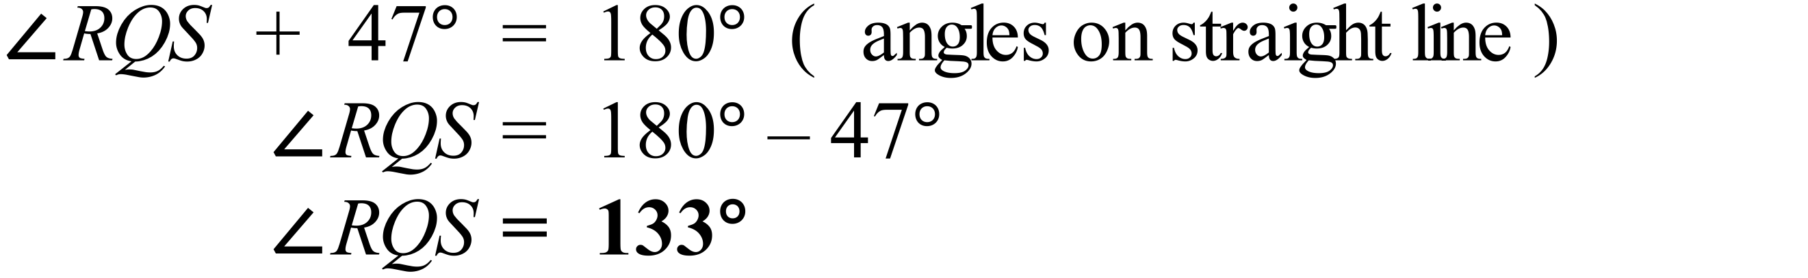
 | 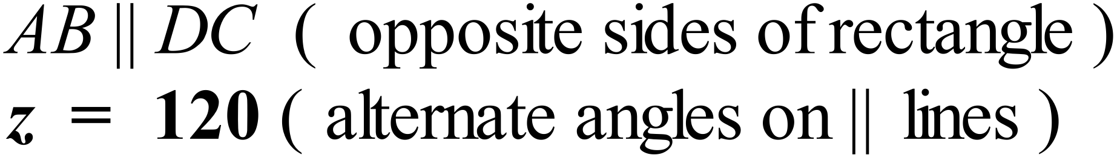
 | 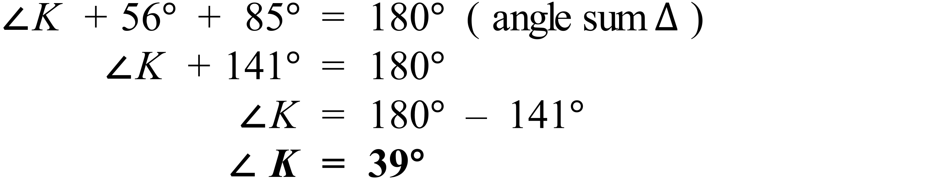
 | 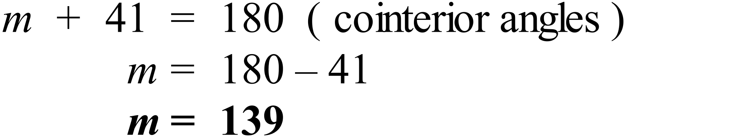
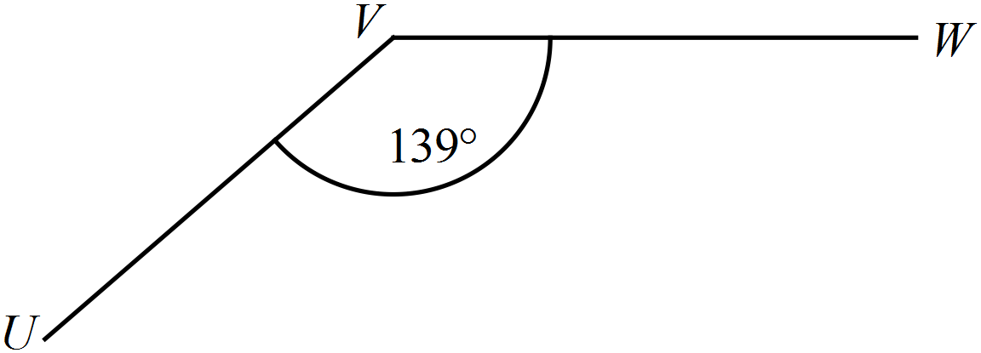

Allow answers from 138º to 140º.
 | 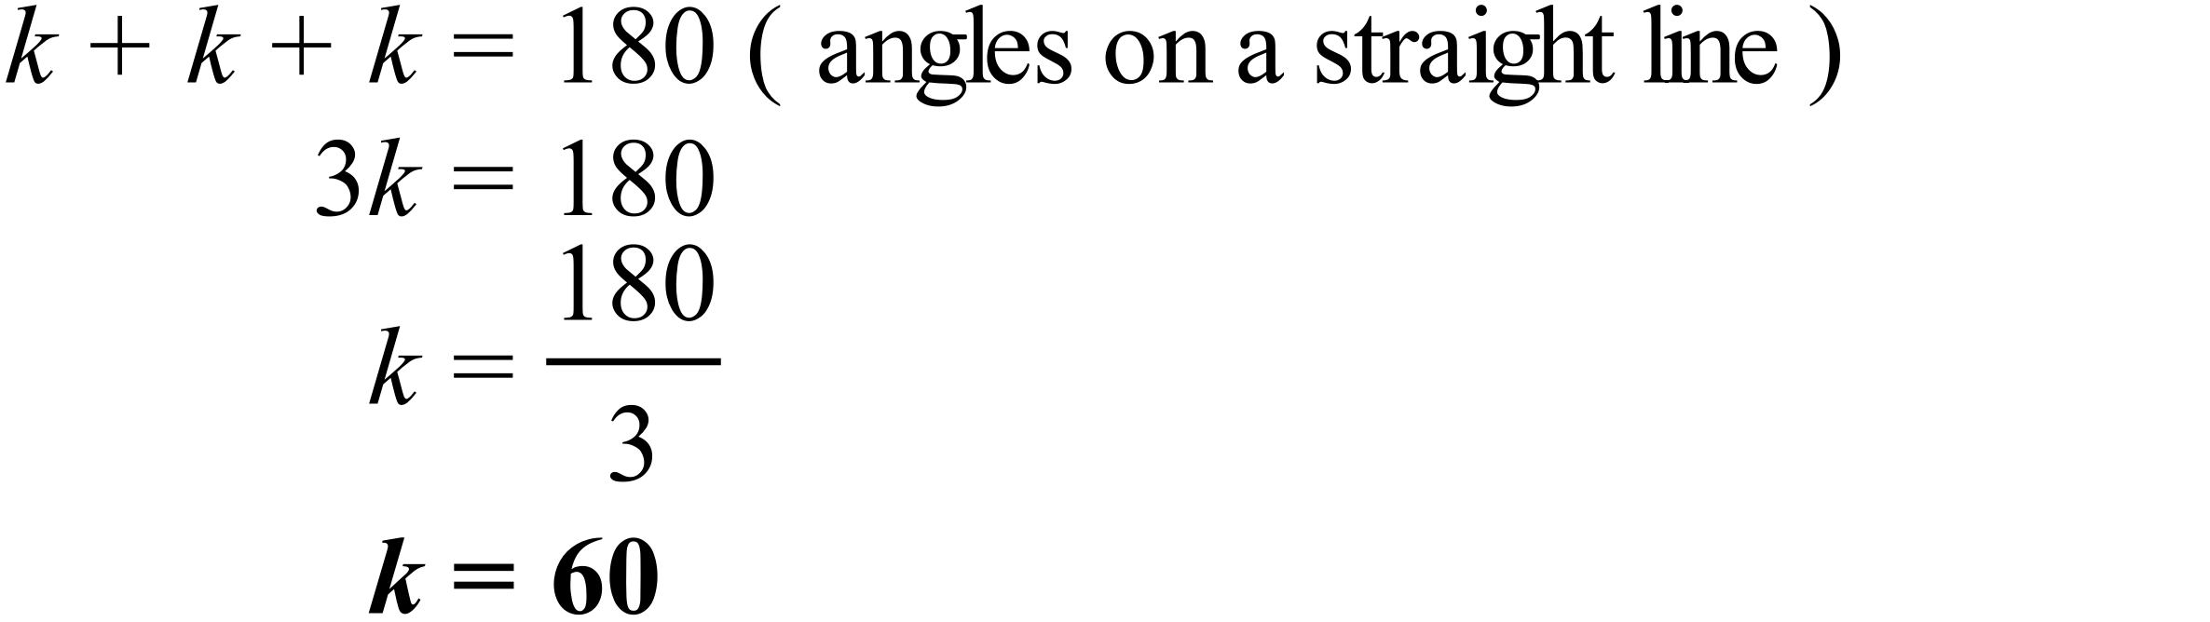
 | 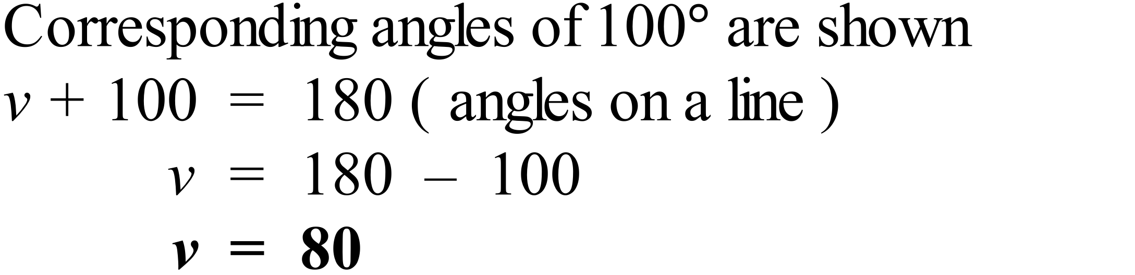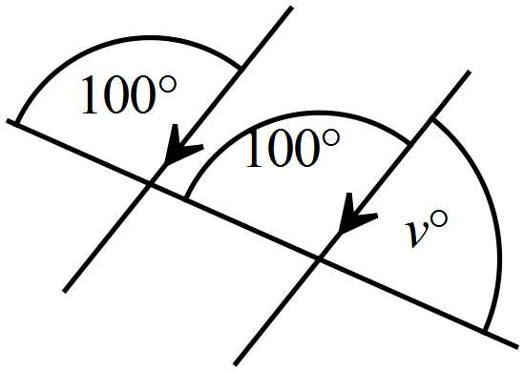
One possible example of an obtuse isosceles triangle is shown.
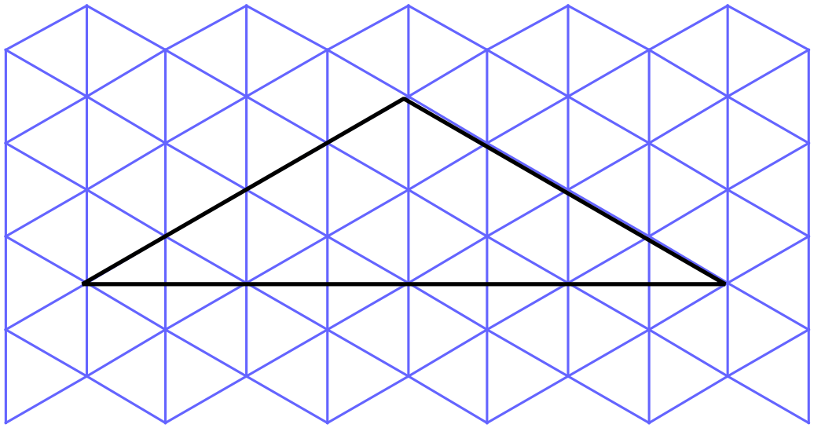

 | 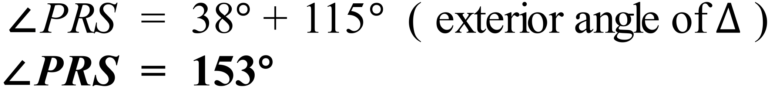
 | 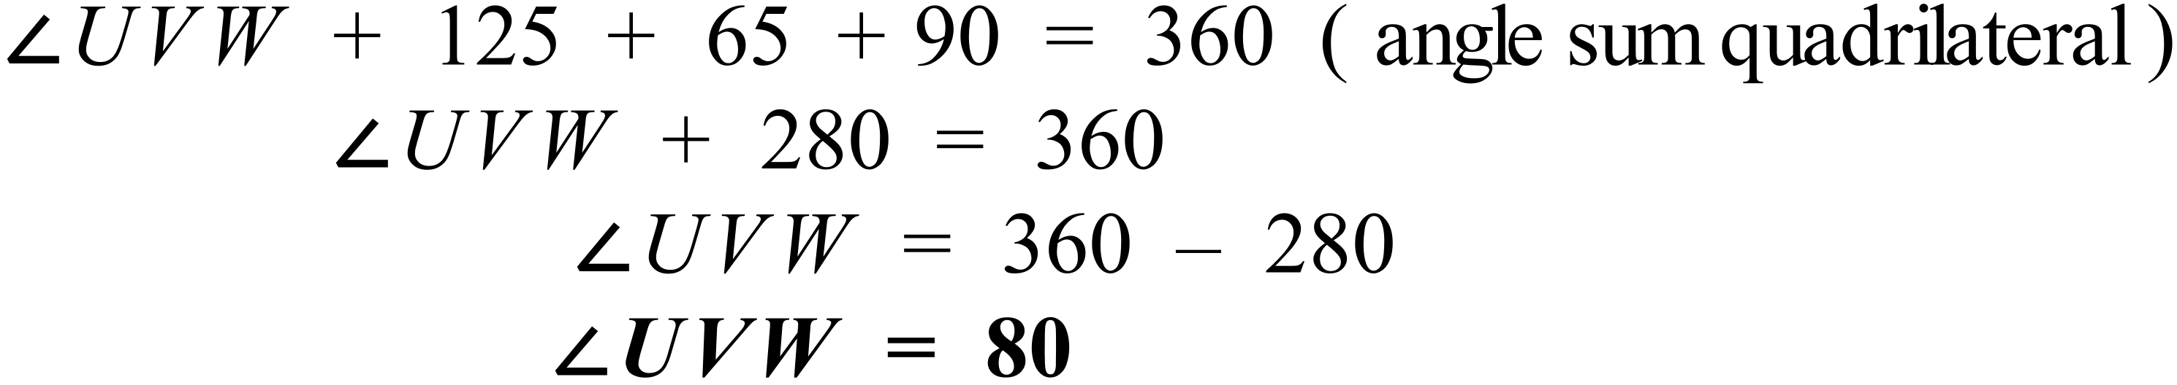
 | 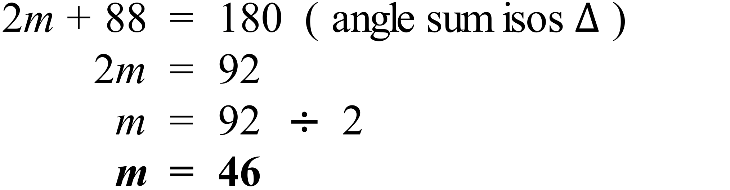
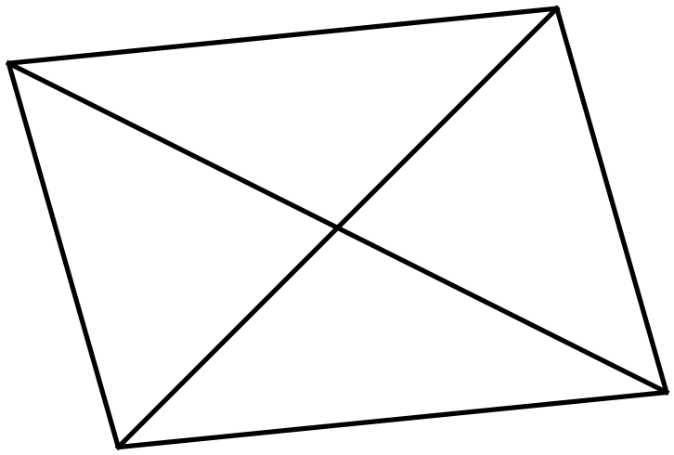

It is a parallelogram.

 | 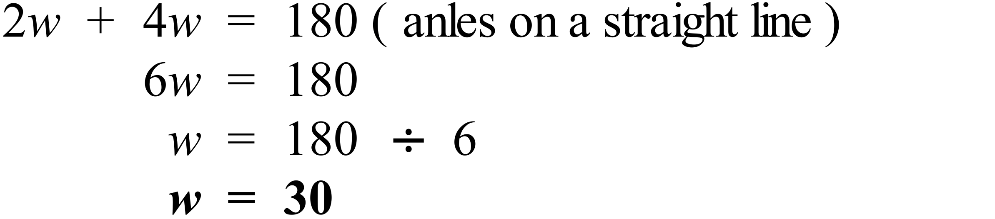
 | 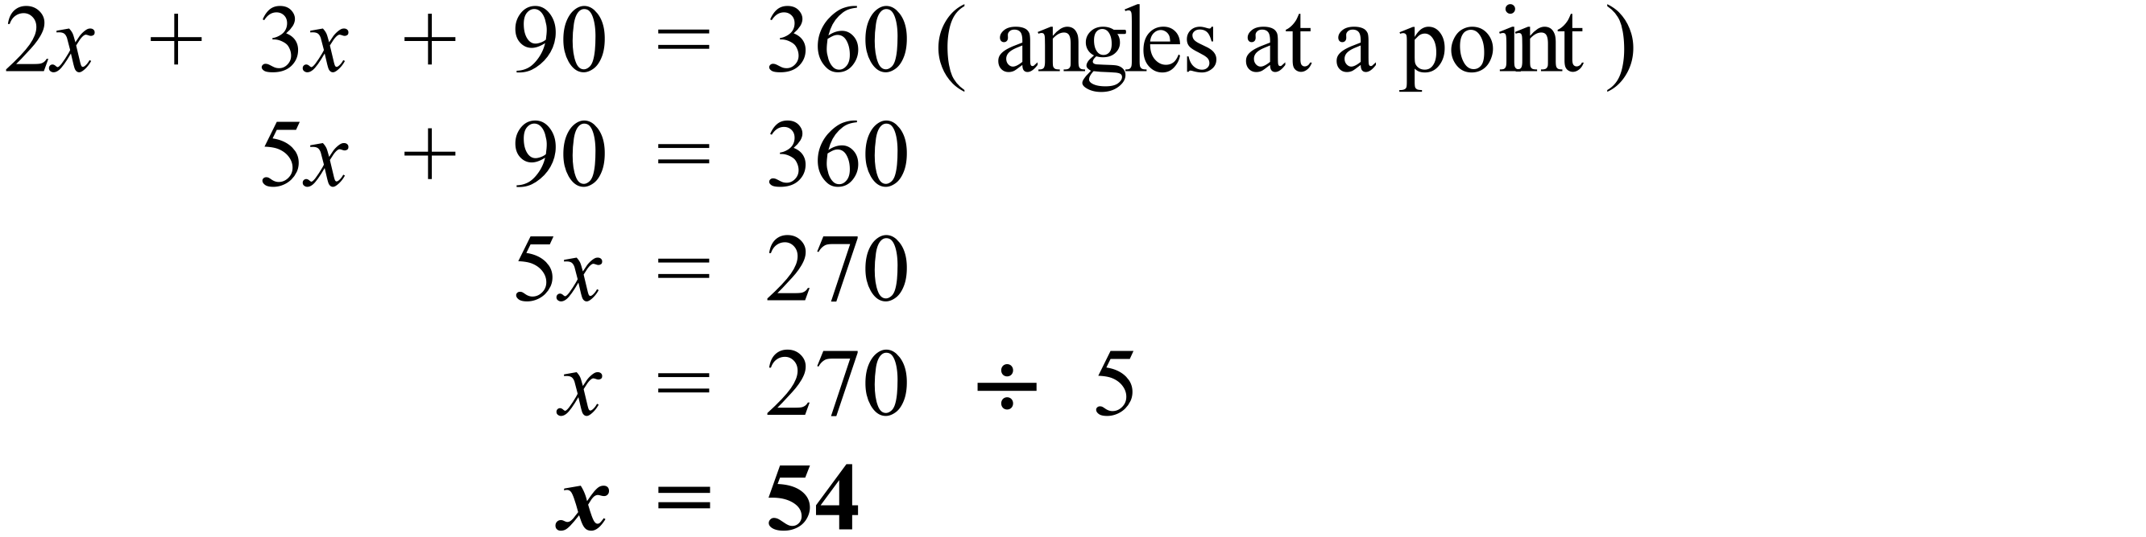
 | 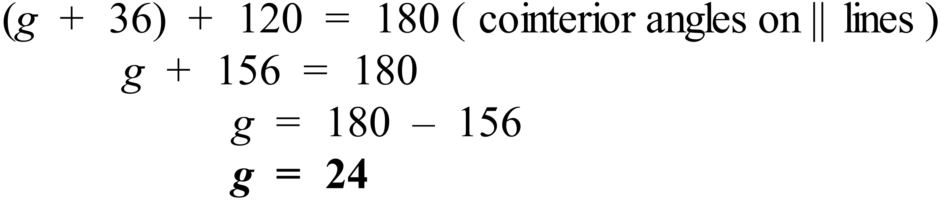
 | 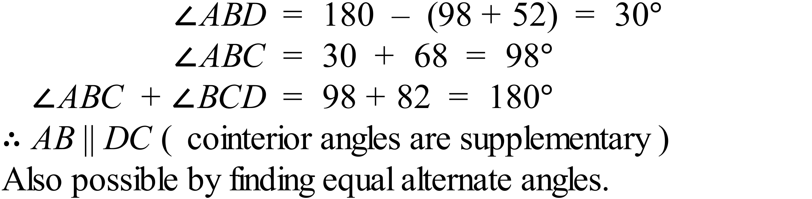
 | 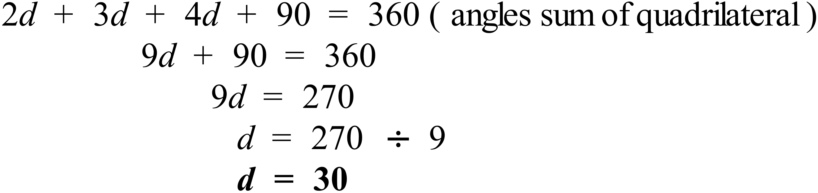
 | 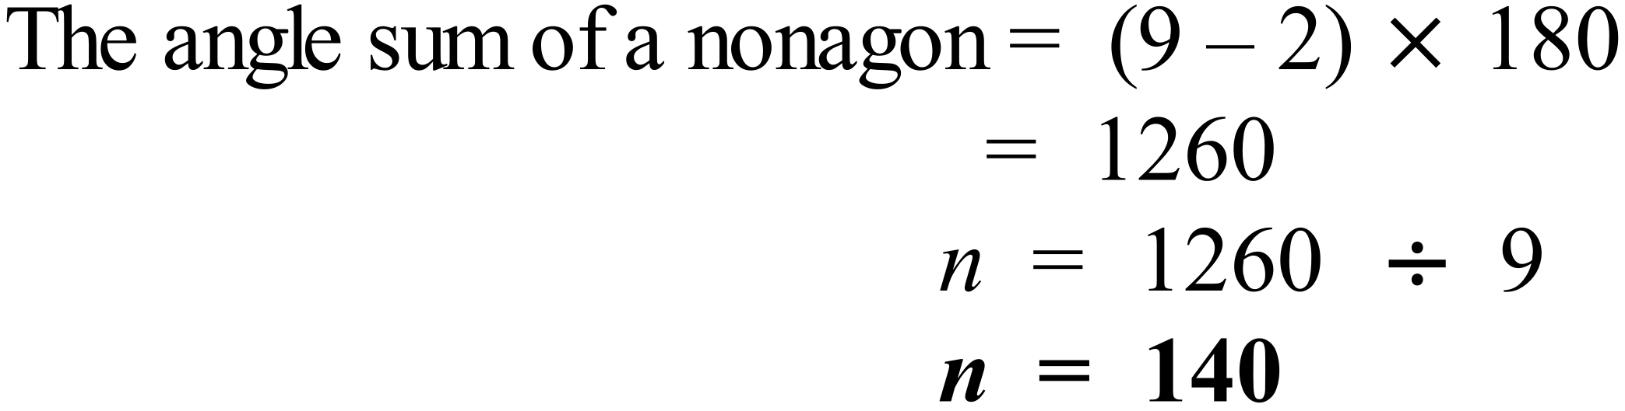
 | 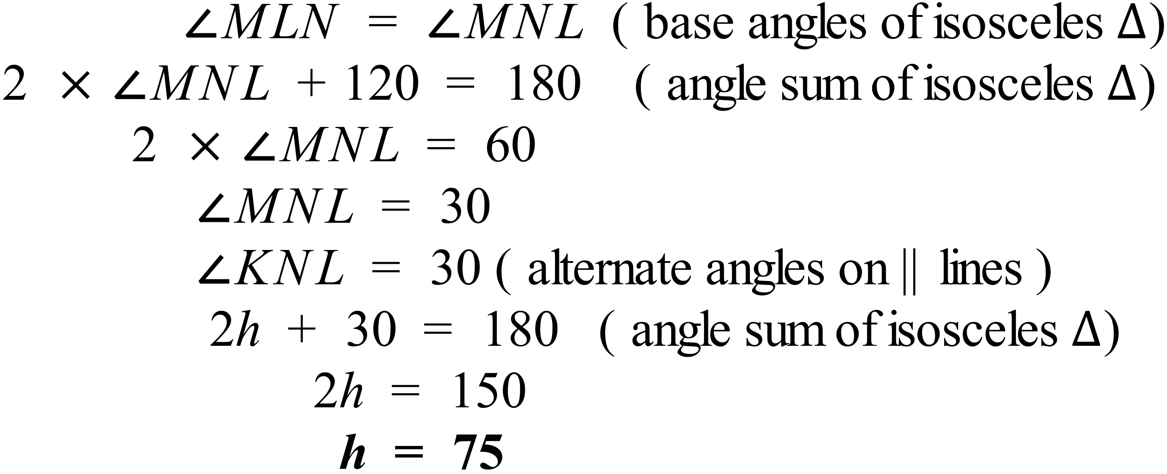
 | 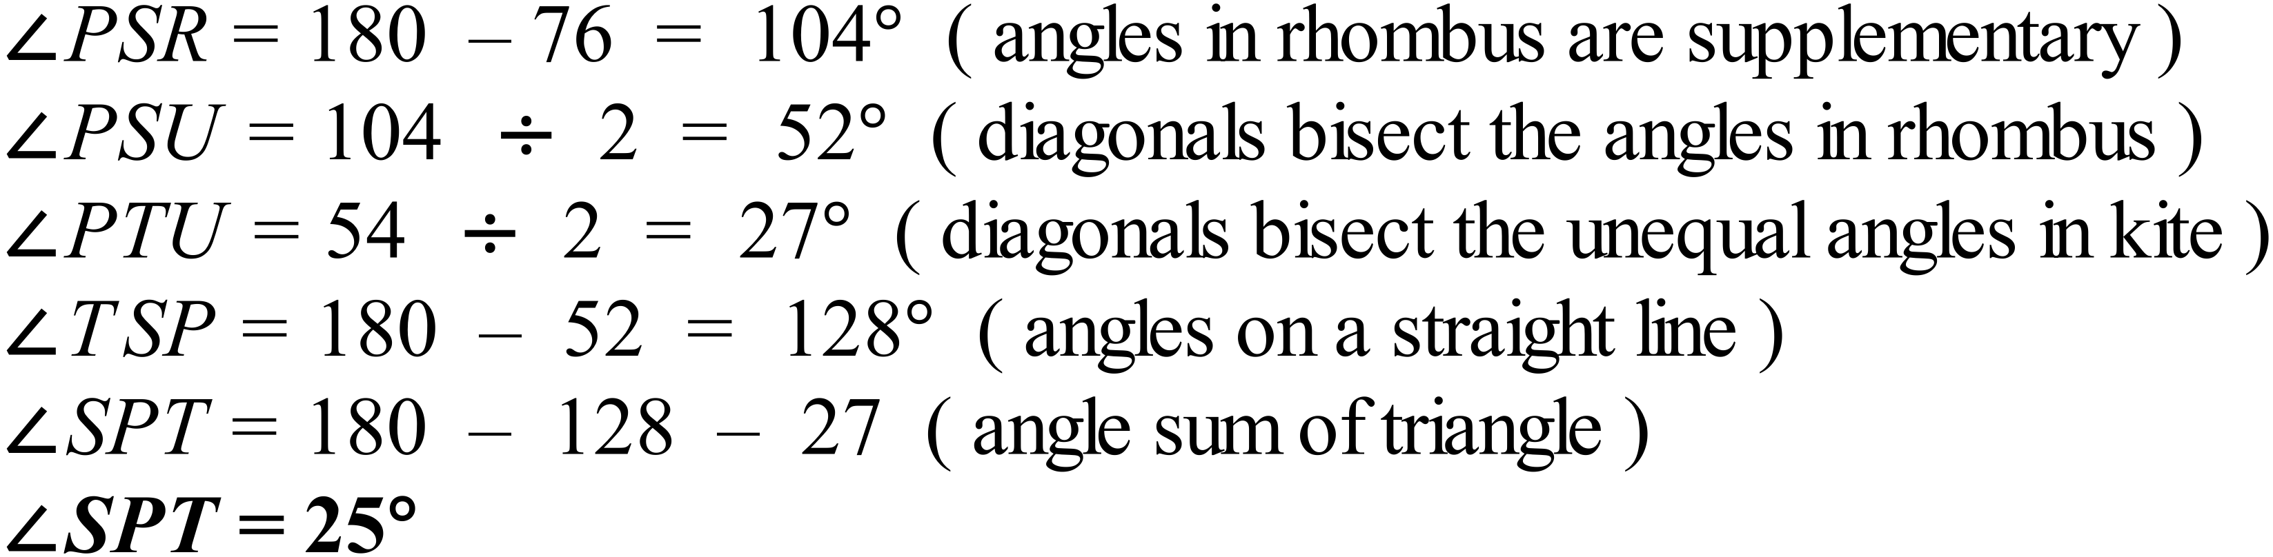

School Name
Mathematics Test 2017
Year 9 | Basic Geometry | Calculator Allowed  Short Answer  Section

ANSWERS

Question | Working | Answer
 | 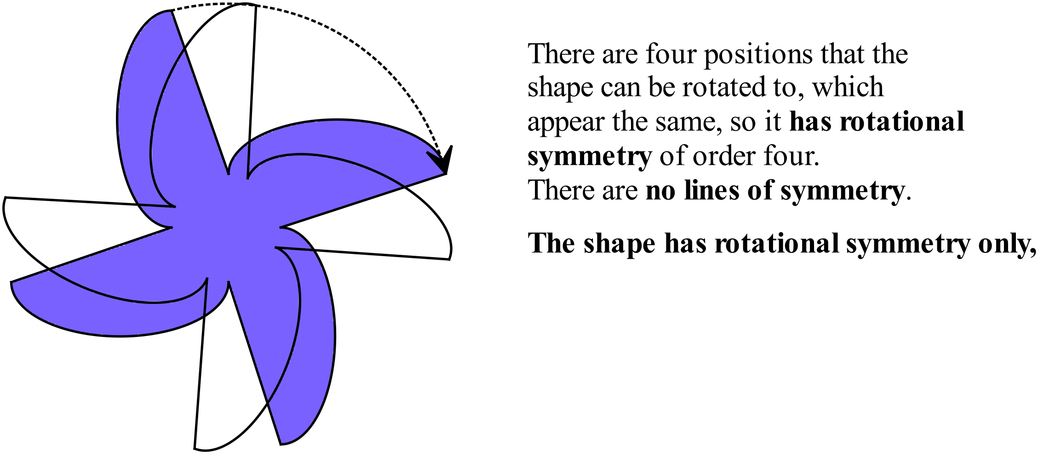 | D
 | A reflex angle is greater than 180º so it makes more than half a full revolution, so this is only A and C.  Of these, in Option A, the reflex angle is marked while in Option C it is marked as 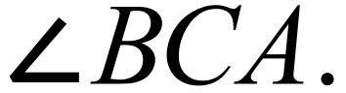 | A
 | 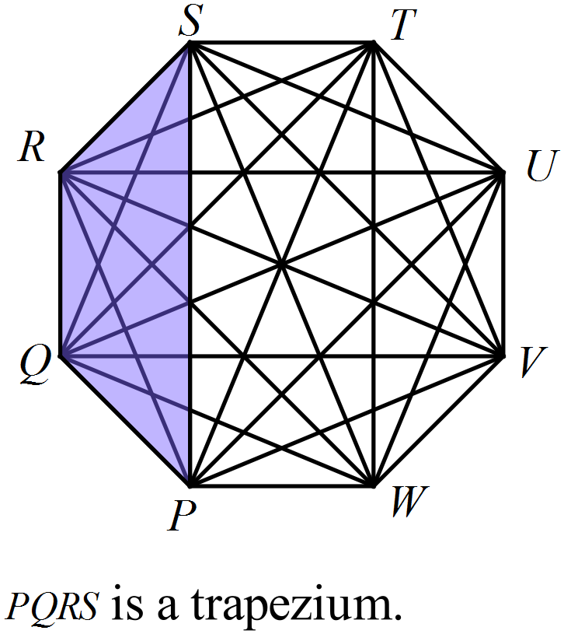 | D
 | 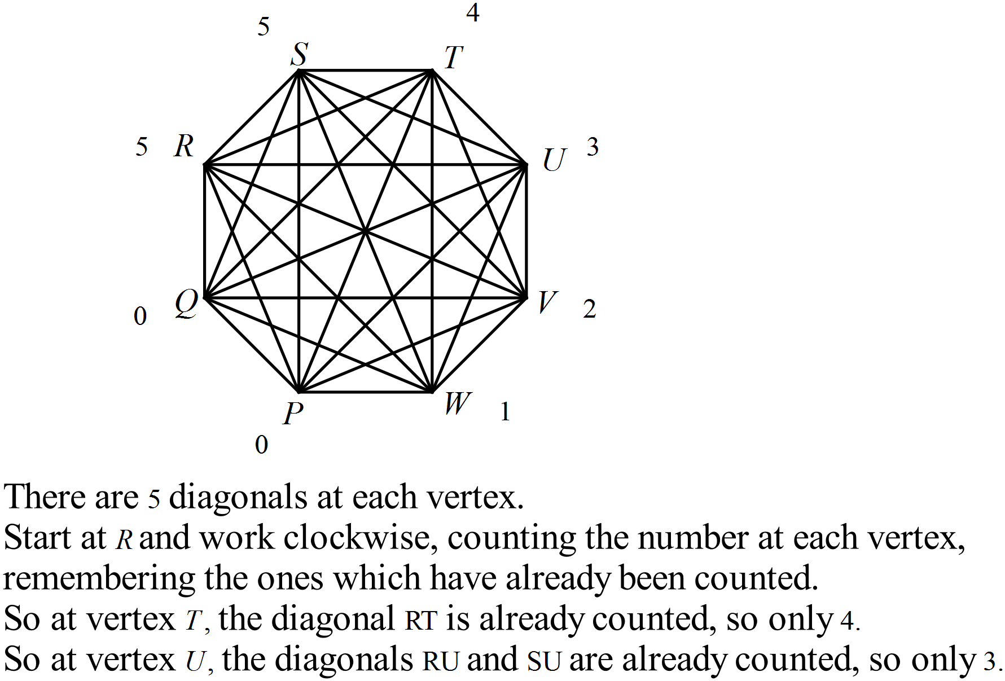  Total = 5 + 5 + 4 + 3 + 2 + 1 = 20  OR 8 vertices × 5 diagonals at each vertex = 40.  Each diagonal is counted twice, so there are 20 diagonals. | B
 | 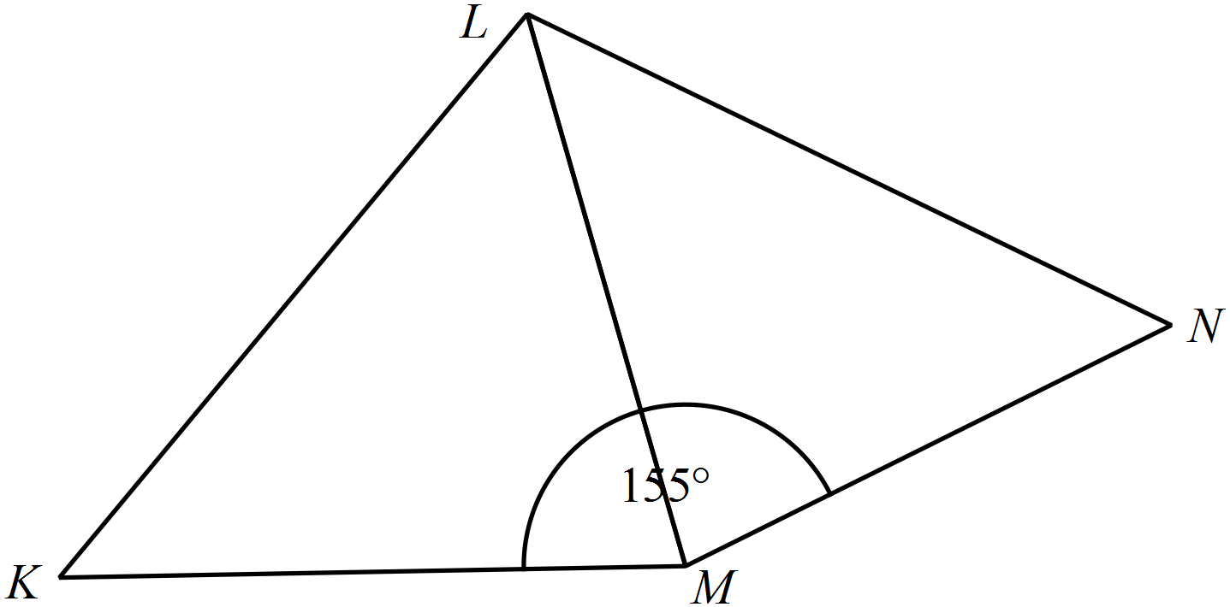Using a protractor: | C
 | 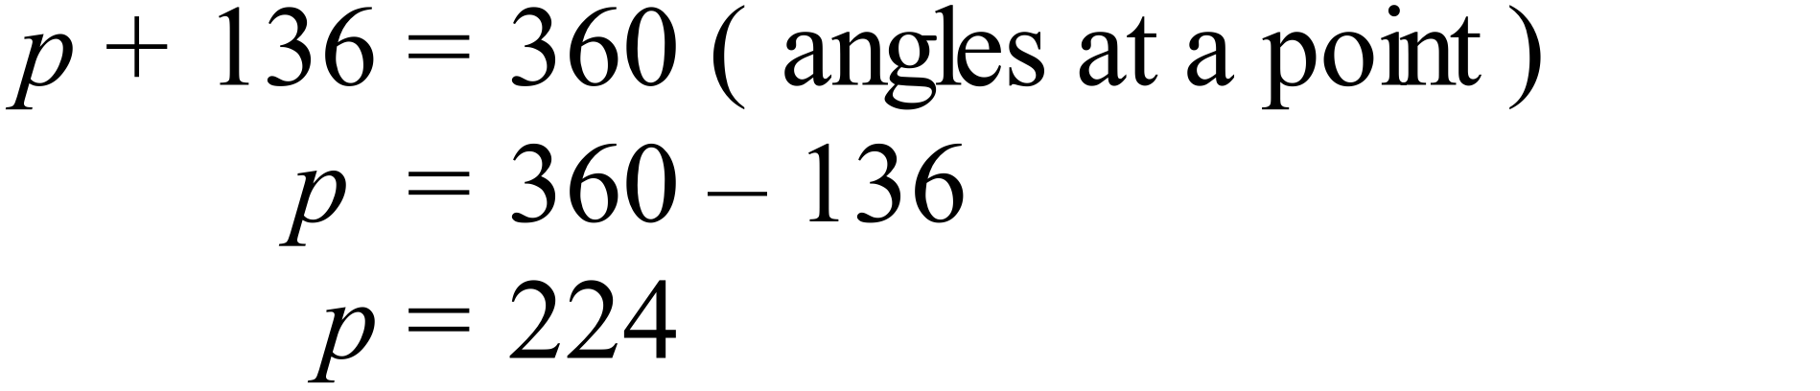 | C
 | 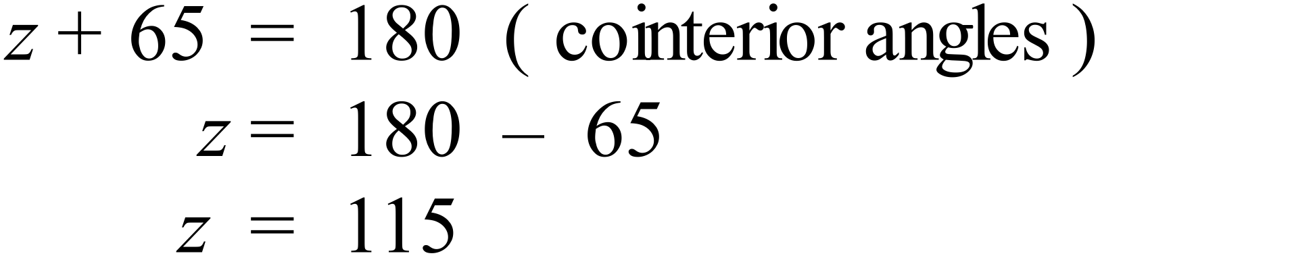 | C
 | 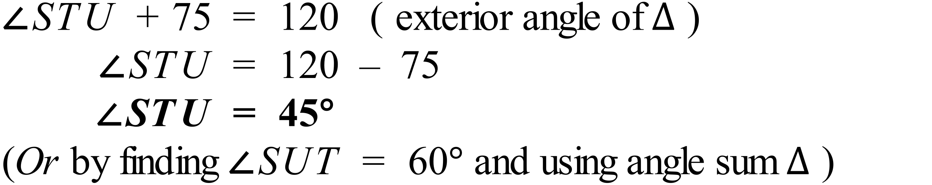 | B
 | 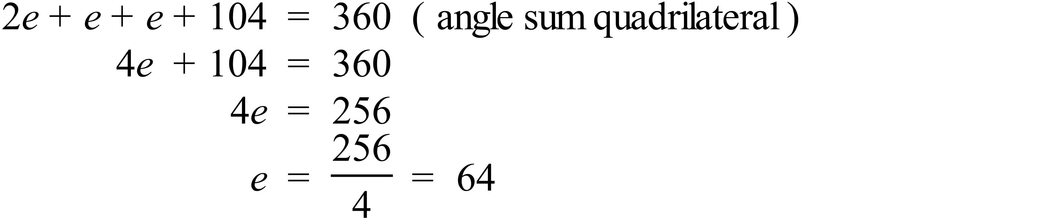 | A
 | 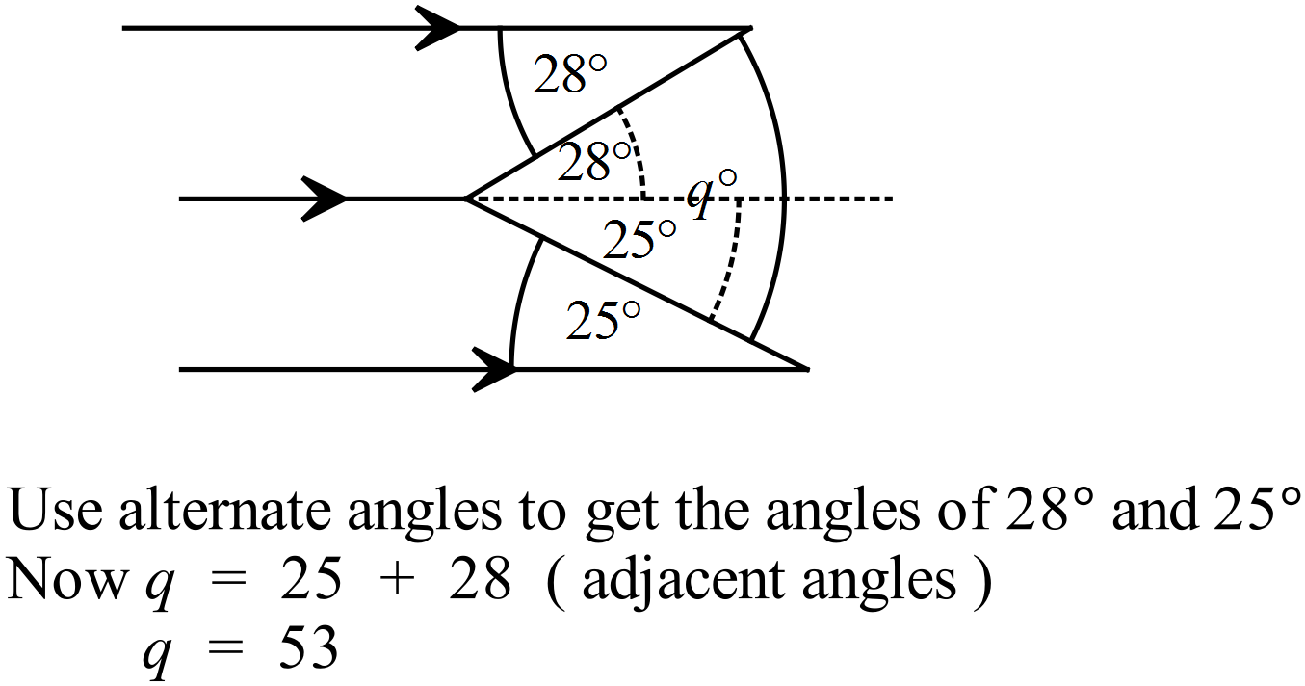 | C
 | It is a parallelogram  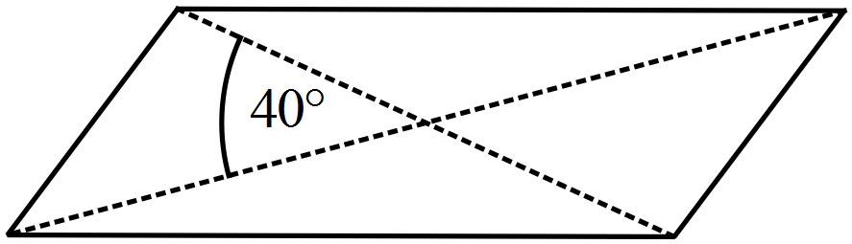 | A
 | 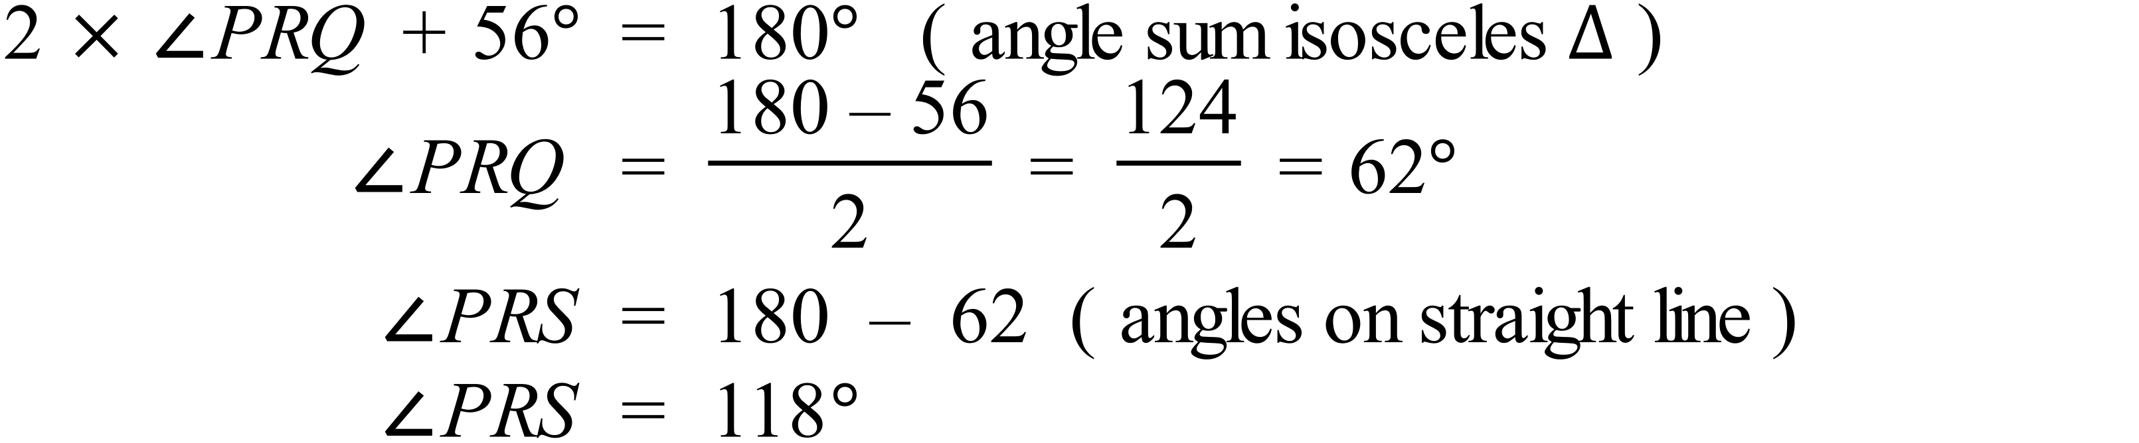 | C
 | 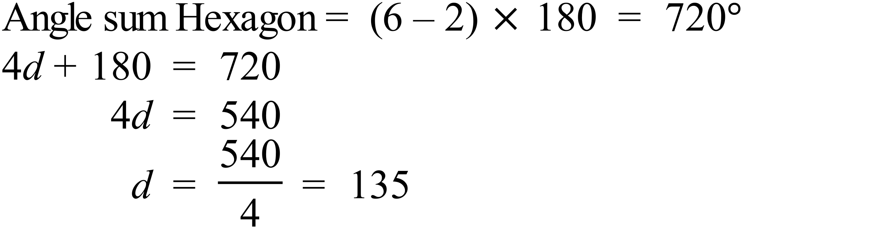 | D
 | 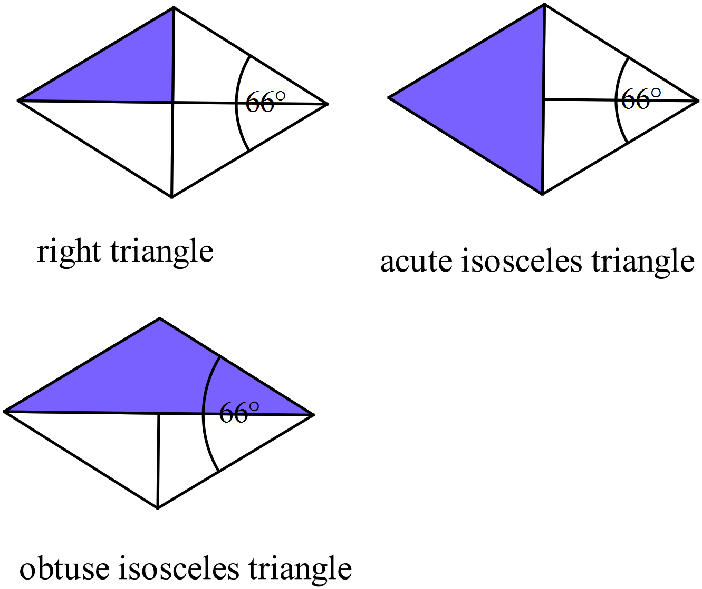  An Acute equilateral triangle is not formed. | B
 | 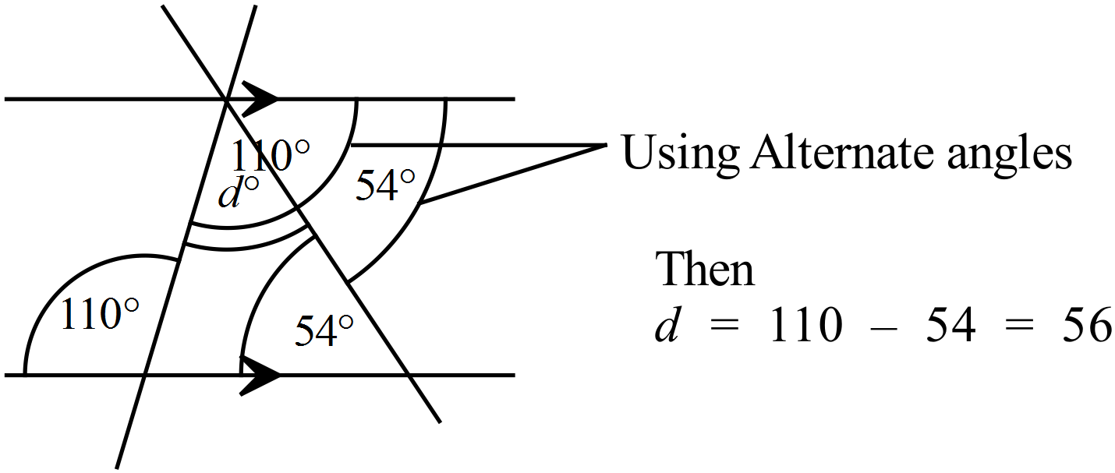 | C
 | 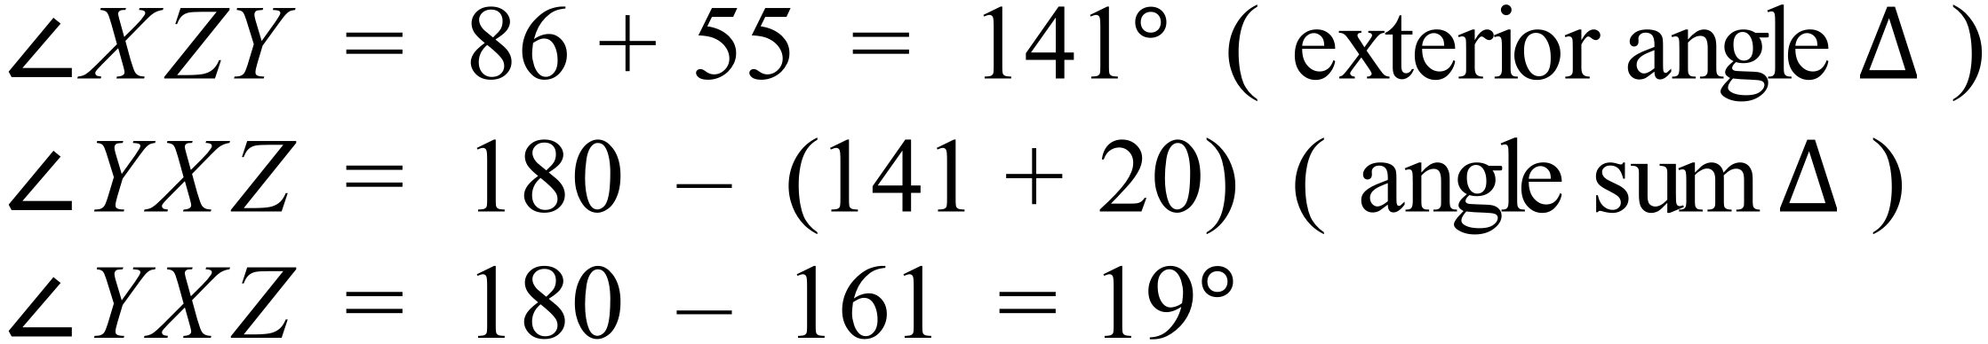 | A
 | 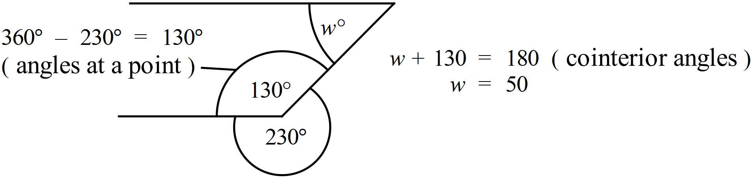 | B
 | 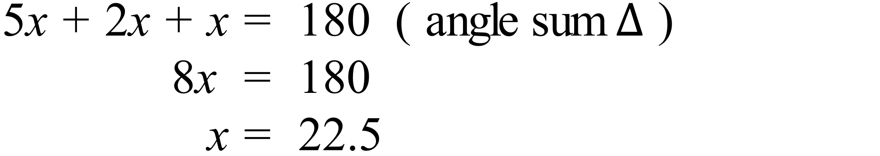 | D
 | 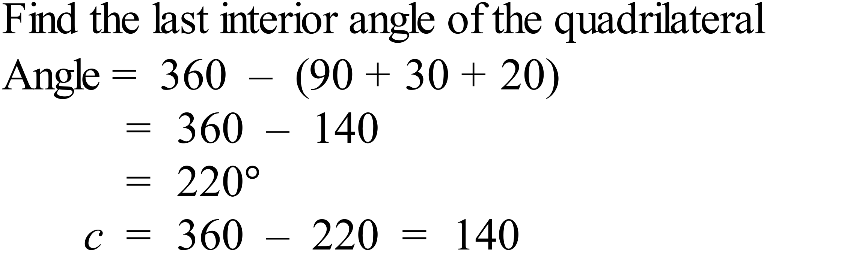  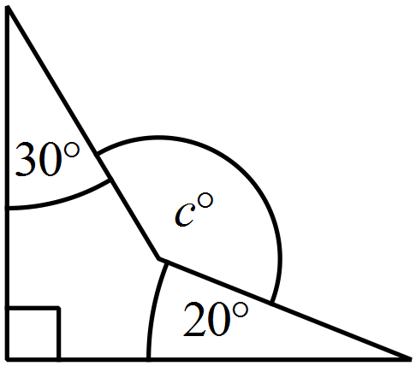 | A
 | 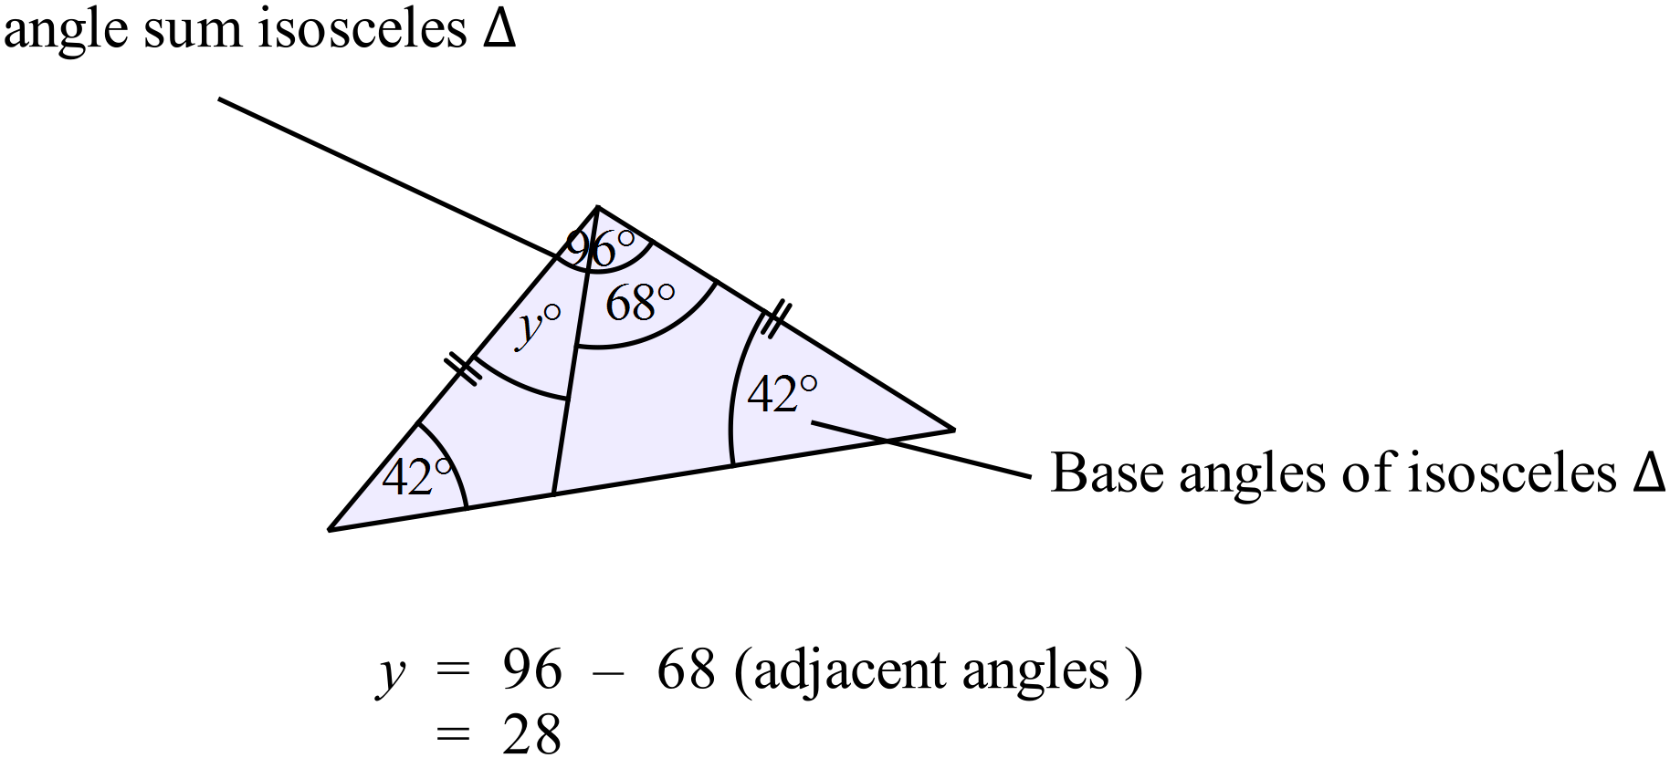 | B

School Name
Mathematics 2017
Multiple Choice Answer Sheet
Basic Geometry
Name _____________________________________________
Completely fill the response oval representing the most correct answer.
1. A B C D
2. A B C D
3. A B C D
4. A B C D
5. A B C D
6. A B C D
7. A B C D
8. A B C D
9. A B C D
10. A B C D
11. A B C D
12. A B C D
13. A B C D
14. A B C D
15. A B C D
16. A B C D
17. A B C D
18. A B C D
19. A B C D
20. A B C D

School Name
Mathematics Test 2017
Year 9 | Basic Geometry | Calculator Allowed  Longer Answer  Section
ANSWERS
Question | Answer | Marks
1. | (a)  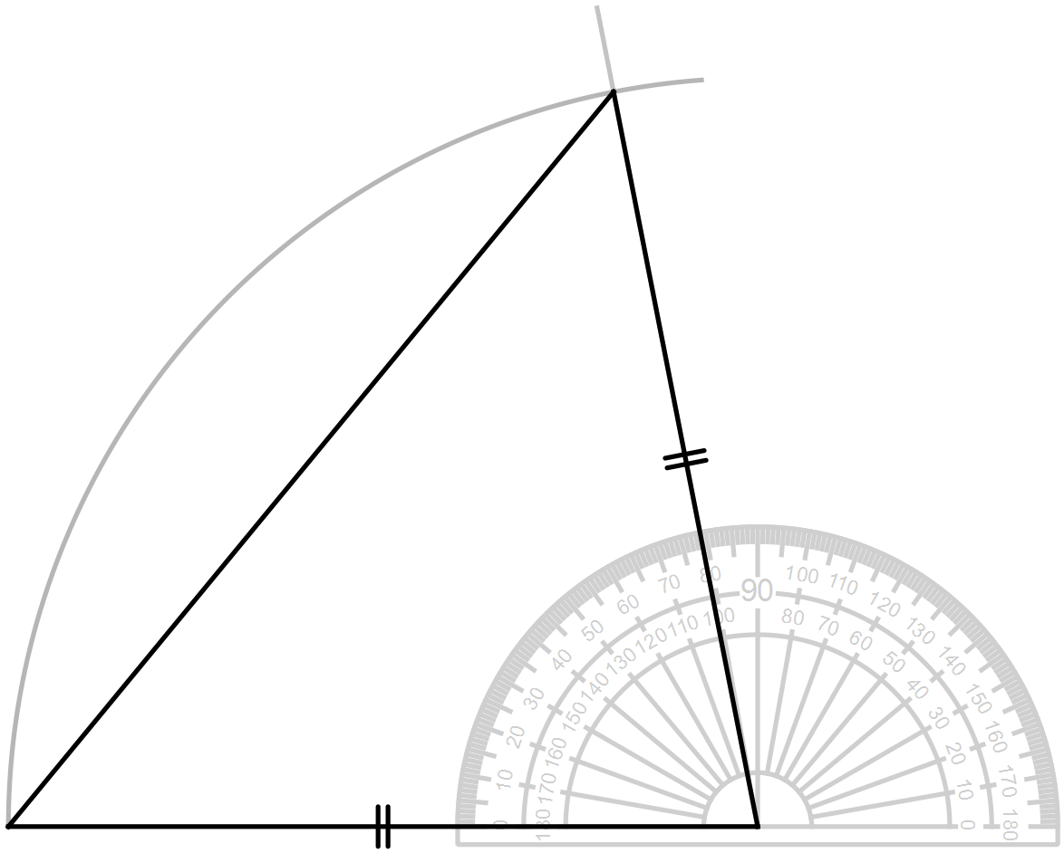 | 2 marks for an accurate and correct drawing with construction lines.  1 mark for a diagram which is inaccurate, slightly incorrectly done or missing construction lines.
 | (b)  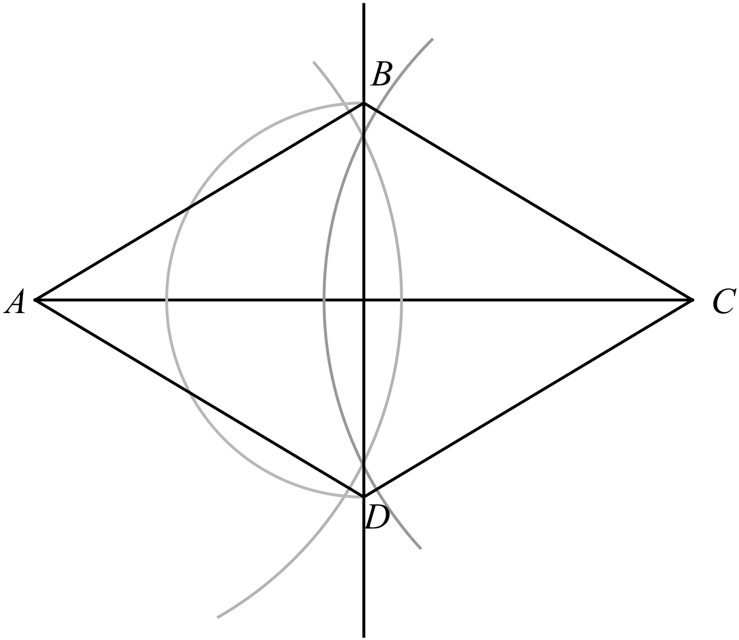 | 2 marks for an accurate and correct drawing with construction lines.  1 mark for a diagram which is inaccurate, slightly incorrectly done or missing construction lines.

